**MINDLINK**



**HRMS**

**(HUMAN RESOURCE MANAGEMENT SYSTEM)**

**USERMANUAL**

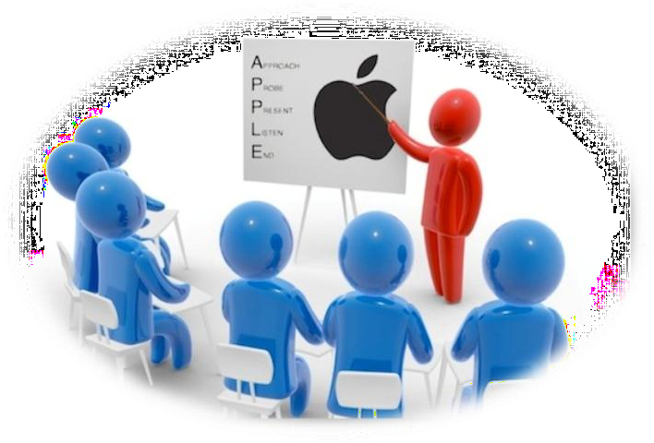



Version 0.1

Contents

1. INTRO 3

SYSTEMOVERVIEW 4

2. SYSTEMSUMMARY 5

MODULES OF MINDLINK 5

3. GETTING STARTED 6

FORGET PASSWORD 7

4. SELF DESK 8

5. DASHBOARD 9

6. EMPLOYEE MANAGEMENT 12

i. Employee 12

ii. Employee Exit Checklist 24

8 Masters 25

i. Department 25

ii. Awards Management 26

iii. Policy Category Management 26

iv. Main Category and Sub Category 27

v. Conference Booking 28

9 Manage Leaves 30

i. Add Leaves 30

ii. Allocated Leaves 31

iii. Manage Holiday 32

10 Timesheet 32

11 Recruitment 34

1. Hall of Fame 37

2. Attendance 38

3. Manage Project /Client 39

4. Appraisal 40

5. Asset Management 41

i. Asset Master 41

ii. Asset Allocation 43

iii. Asset Audit 44

6. Quotes 44

# INTRO

**MINDLINK Portal** provides multiple accesses for users of different departments based on role specific content. Users can access **MINDLINK Portal** once they have been authenticated in the portal which offers a single point of access to information and services both inside and outside the organization. All the modules of **MINDLINK** should be accessed through portal internet /intranet.

This manual is all about the functioning of HRMS software, the manual guidelines you through various

applications which are present in MINDLINK and helps you to easily understand the system.

# SYSTEMOVERVIEW

**MINDLINK** is having the capability to maintain single model database, capturing all personal and job related data of all kind of employees. Mind Link maintains proper data for the functioning of the HR/Associates department. It automates every process happening in all departments like HR/IT/Sales. Also all the data about the Organizations are digitally stored when the **MINDLINK** software comes in to work.

The longevity of an organization solely depends on the healthy and strong relationship between the associates and their management. It doesn’t matter how big or small the organization, it is the mutual concern and trust that binds together the associates and organization, ultimately underlining the growth expansion of business.

**MINDLINK** can act as the third party, bridging the gap between organisation and its associates. It helps in streamlining the entire communication and functions within the business like managing the employee, disseminating company’s updated policies, handling employee job applications, handling the leaves and benefits and more.**MINDLINK** make sure that no space for confusions or human errors is left behind.

# SYSTEMSUMMARY

## MODULES OF MINDLINK

**HR Role Features**

* User Management
* Leave Management
* Recruitment Management
* Project Management
* Asset Management
* Employee Management
* Appraisal Management

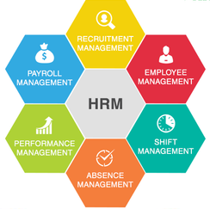

# GETTING STARTED

Listed below are the steps to be followed by **HR** to logon to **MIND LINK** portal application:

LOGIN

**Step 1:** Enter the URL in IE (Internet Explorer version 8, 9 and 10) or Mozilla or Google chrome browser.

**Step 2:** Click on **‘Enter’** button on your keyboard to navigate to MINDLINK Portal login page and enter the

link **“**www.hrms.mindworx.in/Auth/login**”**.

You can access all the portal applications by getting logged on to HRMS portal.

Below listed are the First time ‘login instructions’ to the end user:

On the **‘Login screen’**, enter your existing **‘Email Id’** used for accessing MINDLINK Portal system.

Enter the **‘Password’** which has been provided by the administrator through communication mail.

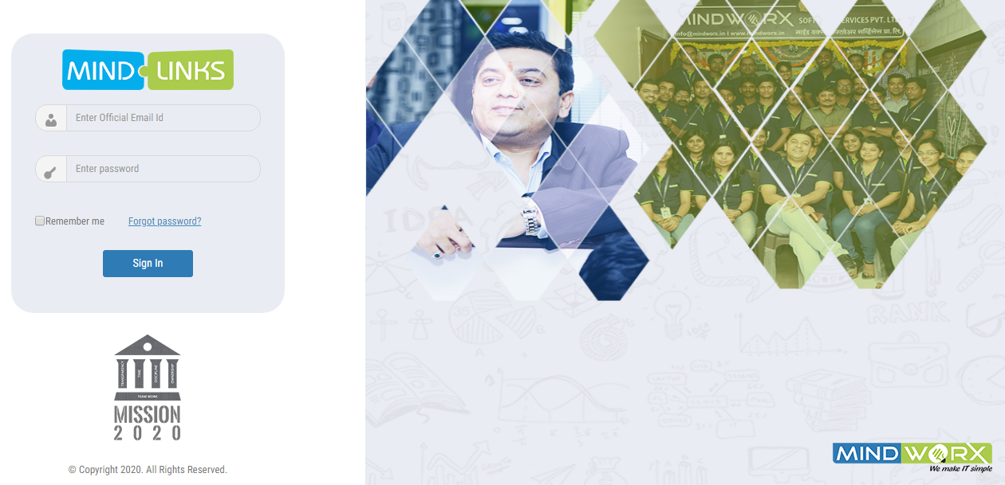



*If you are unable to perform the login process or for any other queries, please do contact*

*Admin.*

## FORGET PASSWORD

The user has been provided with an option of changing the password if he / she forget the password.

**Step 1:** Click on the **Forget Password** link.

You will be navigated to the below shown screen.

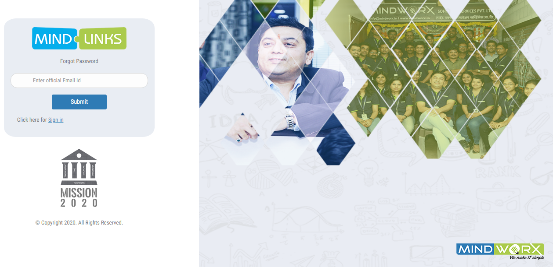

**Step 2:** Enter official Email id and Click on **SUBMIT** button.

# SELF DESK

The self desk module of HR gives details about all other activities as explained below:

1. **Profile Information**-User view his/her profile info like name, designation and experience.
2. ***Hall of Fame/Birthdays-***  The associate’s name whose birthday falls or awarded

by hall of fame view by user

1. ***Leave Info-***User view the graphical representation of leaves data.
2. ***Notification-***User view the list of notification of any new timely information related to organization.
3. ***Events-***User view the information of event that happens or going to be happen.

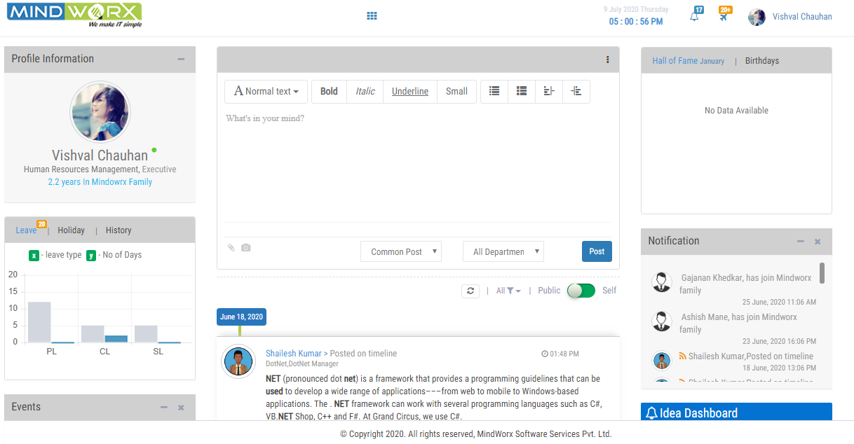

**1**

**3**

**5**

**2**

**4**

BACKEND



# DASHBOARD

All the vital information regarding a company is available from Mind Link dashboard. Important details

Like Employee structure, total client count, timesheets and broad factor are accessible from here with

Just one click.

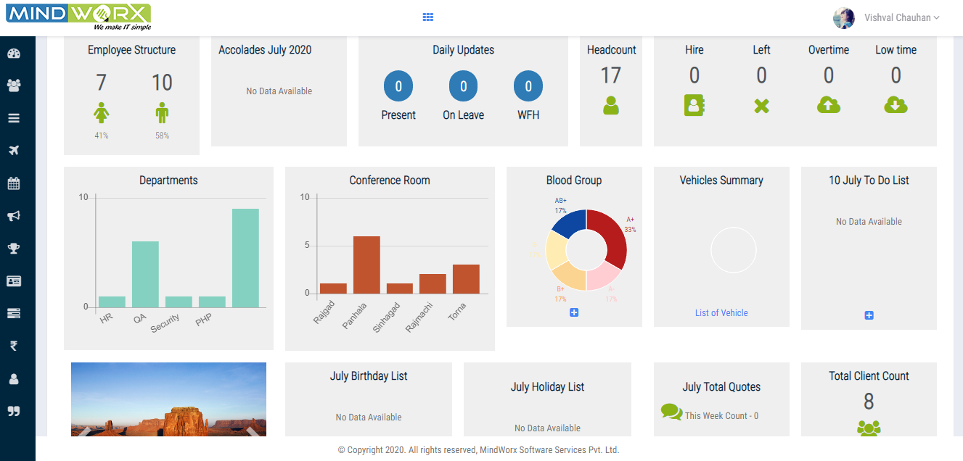

|  |  |
| --- | --- |
| **Icons** | **Description** |
|  | Click to open dashboard |
|  | Click to open Employee management |
|  | Click to create masters |
|  | Click to manage leaves |
|  | Click to manage Timesheet |
|  | Click to manage Recruitment |
|  | Click to add Hall of Fame |
|  | Click to manage attendance |
|  | Click to add Project/Client |
|  | Click to manage Appraisal |
|  | Click to manage Asset |
|  | Click to publish Quotes |

|  |  |  |
| --- | --- | --- |
| 1 | **Employee Structure** | User can view the employee structure in terms of proportion (42% Females and 57% Males) |
| 2 | **Accolades** | Need to discuss |
| 3 | **Daily updates** | User can view the daily updates of number of employee’s presence i.e. who are present or on leave or working from home . |
| 4 | **Headcount** | The count of total number of employees. |
| 5 | **Departments** | The graphical representation of department data. |
| 6 | **Conference Room** | User can view the graphical representation of conference room availability. |
| 7 | **Blood Group** | User can view the pie chart showing the distribution (%) of ABO blood groups in the employees. |
| When user clicks on  icon, a new screen appears which shows the List of employees with their blood group. | | |
|  | | |
| 8 | **Vehicles Summary** | - |
| 9 | **To Do List** | User can track their daily task from To do list. |
| 10 | **Birthday List** | User can view the birthday list of associates whose birthday falls on current month. |
| 11 | **Holiday List** | User can view the Holiday list of current month. |
| 12 | **Total Quotes** | User can view the total count of quotes which was published by HR on current month. |
| 13 | **Total Client Count** | User can view the total count of clients. |
|  | **Policies** | User can view the list of policies and download the relevant policy file. |
|  | | |
| Step1: When user clicks on **Add New Policy** button a below screen appears so he/she can add a new policy by selecting appropriate category.  Step2 : User uploads the appropriate PDF file from system.  Step3: Click on ‘SUBMIT’ button | | |
|  | | |

# EMPLOYEE MANAGEMENT

## Employee

On the employee module screen (which is shown below); User can see list of all the associates

Who are working with your organization; along with their Name, Employee Code and

Designation.

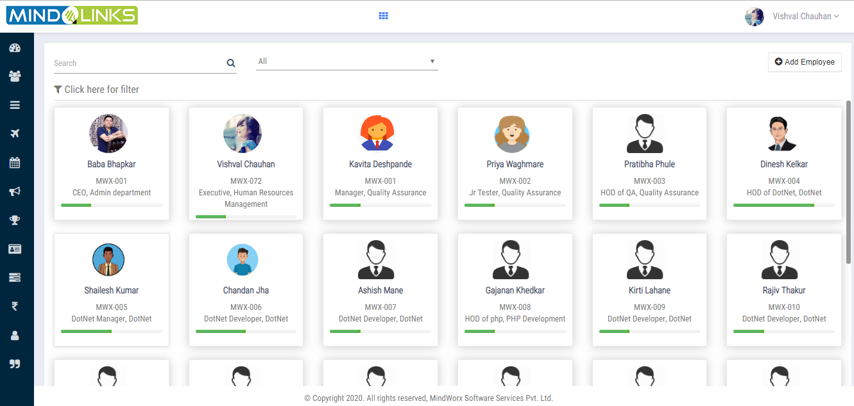

**2**

**1**

**1**

Step1: When user clicks on **Add Associate** button a pop up window will appear.

|  |
| --- |
|  |

Step2: User selects mode of employment i.e. direct or interview then select the candidate.

Step3: Click on submit button.

**2**

When user click on **name o****f employee**, a new window will appear where user can see the

Employee Official, personal, experience, skills, education, Certification and visa details.

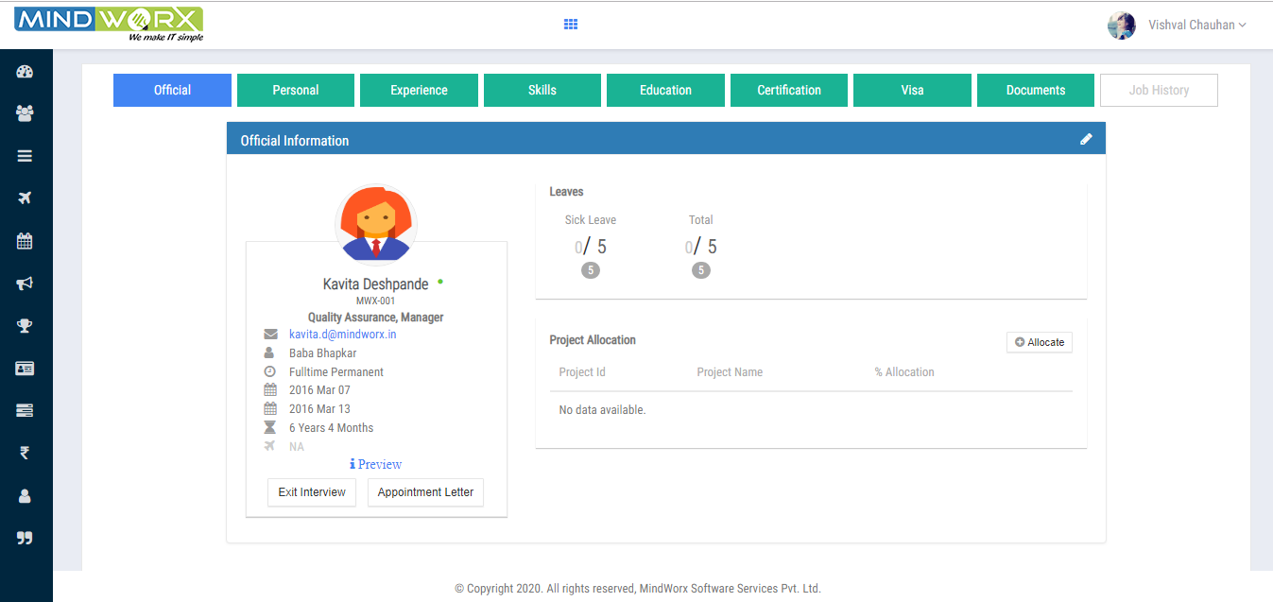

|  |
| --- |
| **Official Information** |

1. When user clicks on **Official**, official information of employee will appear as shows

in above screen.

1. Here user can also view the leave information and project allocation details.
2. When user clicks on  button a pop up window will appear as shows in below

Screen where reporting manager can allocate the project by entering all details then click on

Submit button.

1. The project will be allocated to employee.

|  |
| --- |
|  |

|  |  |
| --- | --- |
| **Icons** | **Description** |
|  | Click to show mail id |
|  | Click to show the Reporting Manager name to whom he/she is reporting |
|  | Click to show the joining and prohibition date |
|  | Click to show the employee status |
|  | Click to show the total experience |
|  | Click to show the associate has passport or not. |

|  |
| --- |
| **Personal Information** |

1. When user clicks on Personal,can see the personal information of employees

like birthday,Gender,Marital status and his/her mail id,

Emergency Contact

Current Address

Hobbies

Language known

Vehicle Details

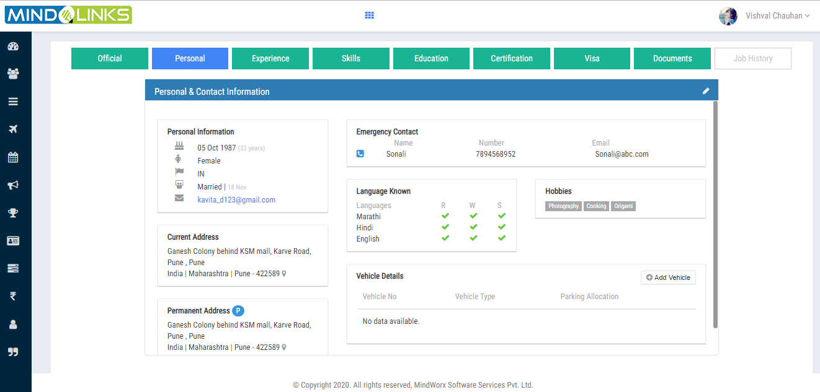

1. When user clicks on  , a pop up window will appear .

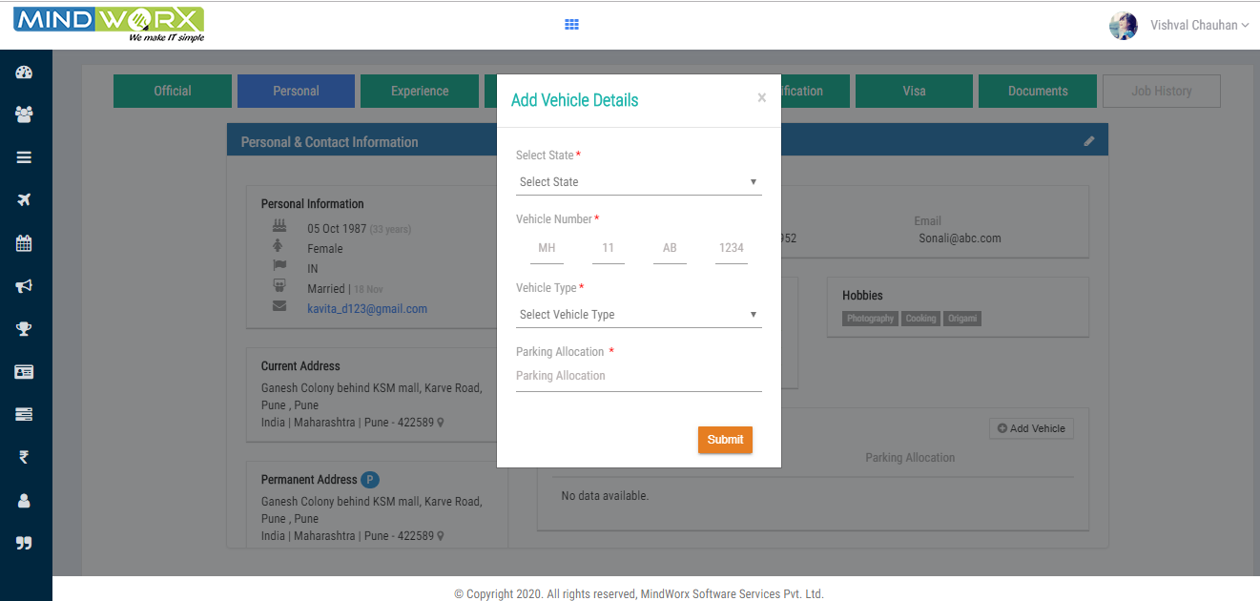

1. Where user can add Vehicle details and click on submit button.

|  |
| --- |
| **Experience** |

1. When user clicks on **Experience** it shows the employee’s work experience details.

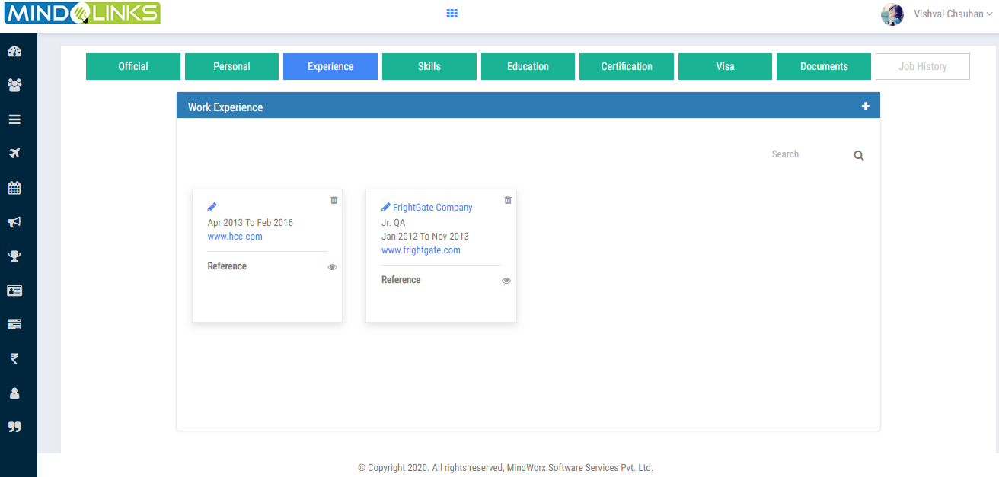

1. If user wants to add more experience then he clicks on  icon and enter the details as

shows in below screen and click on submit button.

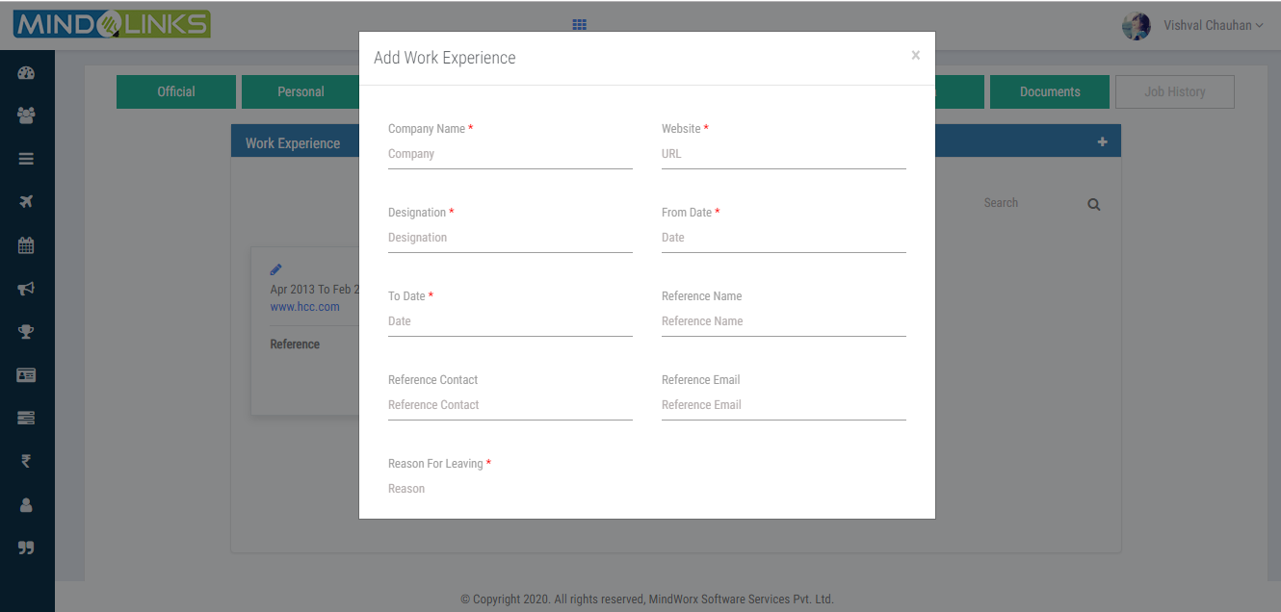

1. On clicking icon user can edit the work experience of employee after enter all the details

as shows in below screen .

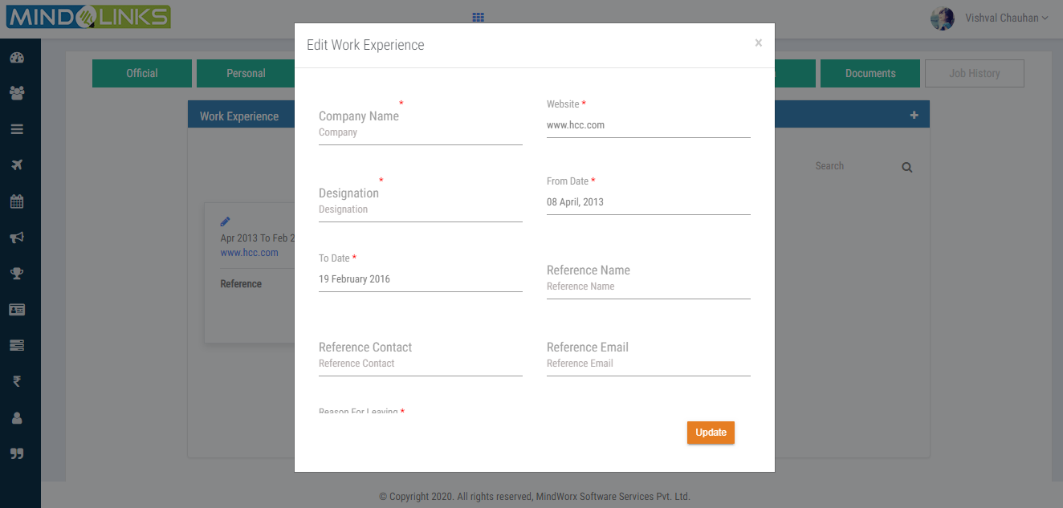

1. Click on update button.

|  |
| --- |
| **Skills** |

1. When user clicks on **Skills it** shows the employee’s skill details.

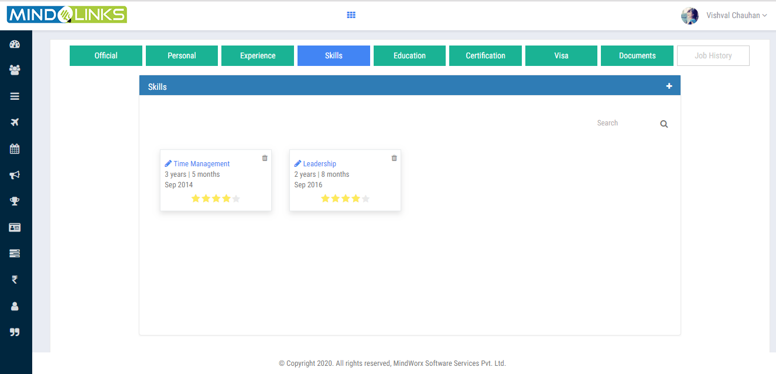

1. If user wants to add more skills then he clicks on  icon and enter the details as

shows in below screen and click on submit button.



1. On clicking icon user can edit the skills of employee after enter all the details as shows

in below screen .

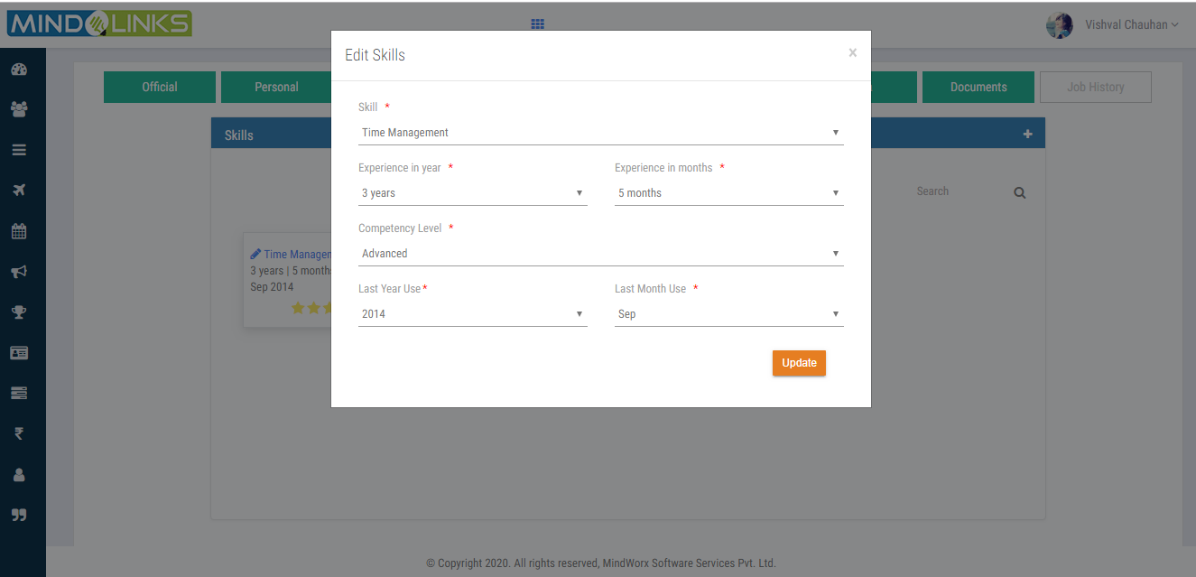

1. Click on update button.

|  |
| --- |
| **Education** |

1. When user clicks on **Education** it shows the employee’s education details.

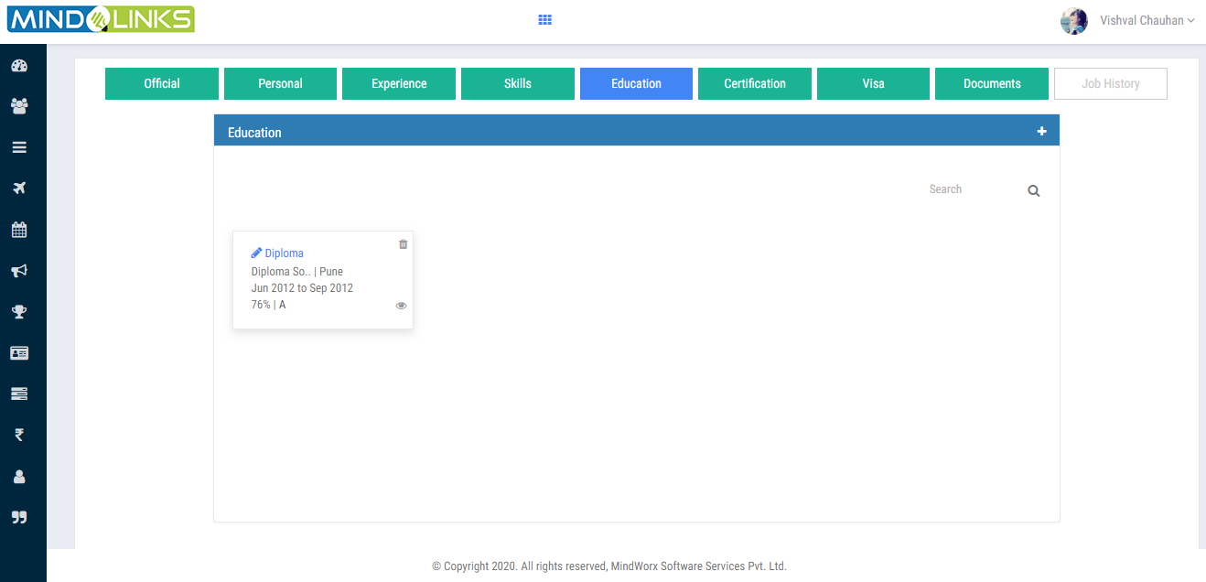

1. If user wants to add more education then he clicks on  icon and enter the details as

shows in below screen and click on submit button.

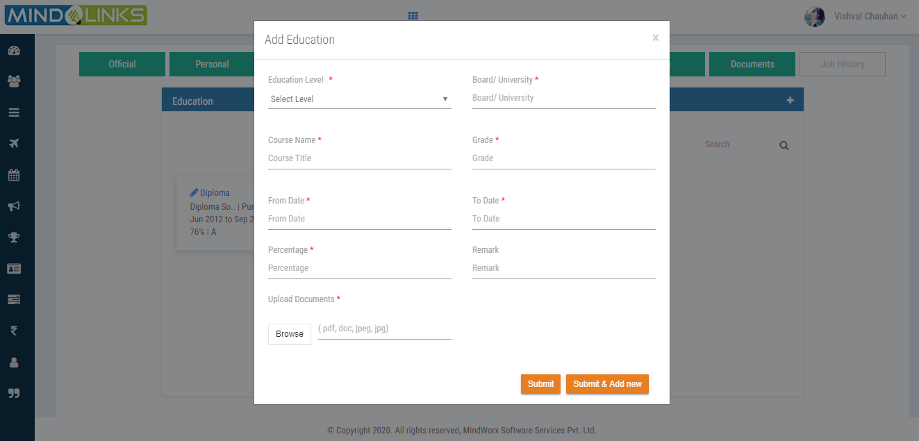

1. On clicking icon user can edit the education level of employee after enter all the details as shows

in below screen .

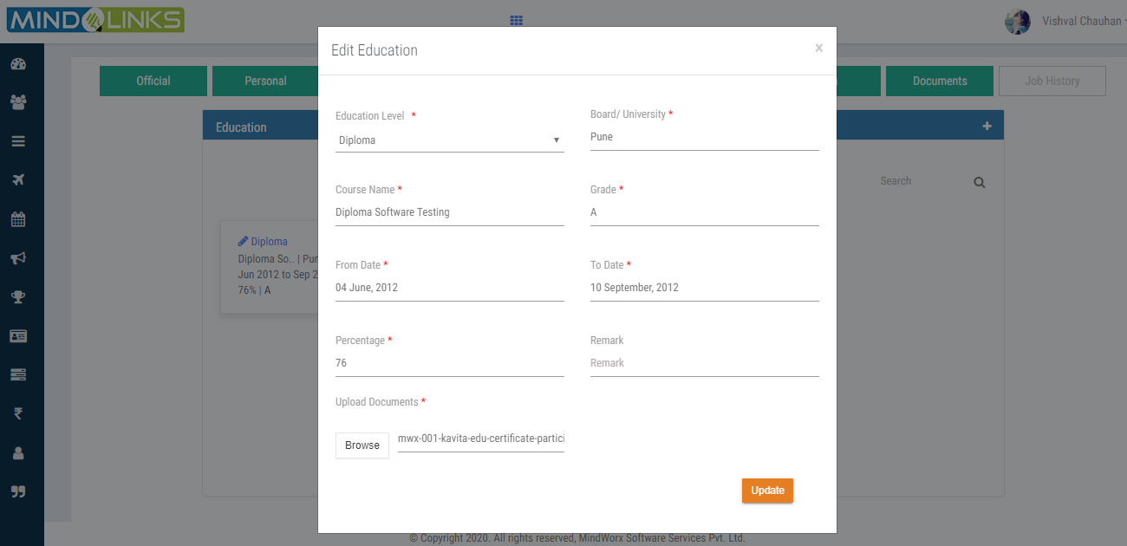

1. Click on update button.

|  |
| --- |
| **Certification** |

1. When user clicks on **Certification** it shows the employee’s certification details.

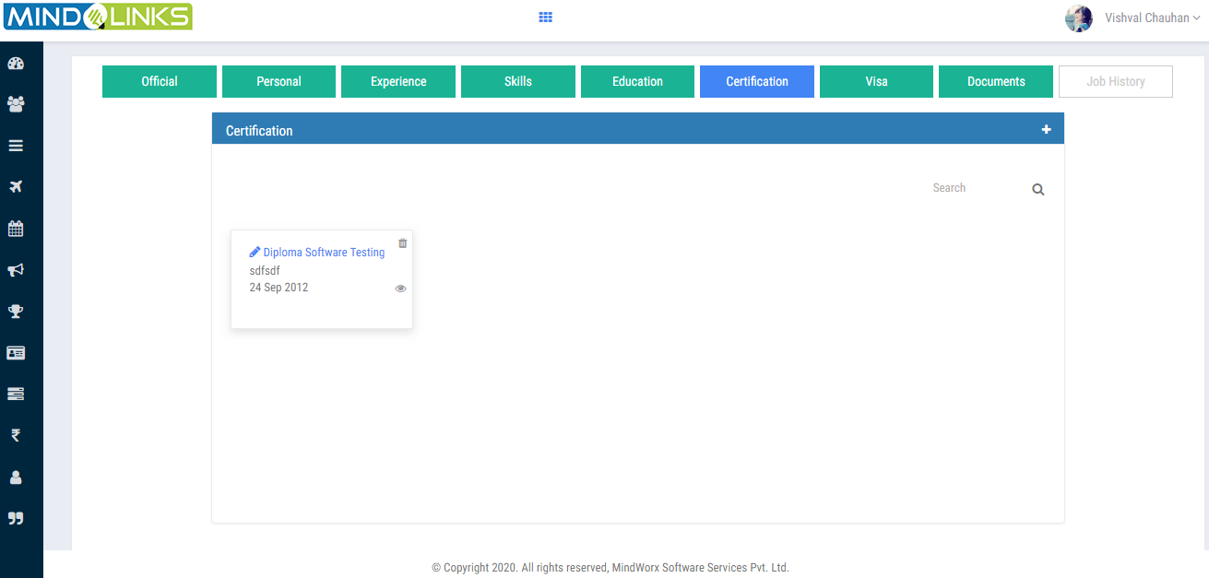

1. If user wants to add more certification then he clicks on  icon and enter the details as

shows in below screen and click on submit button.

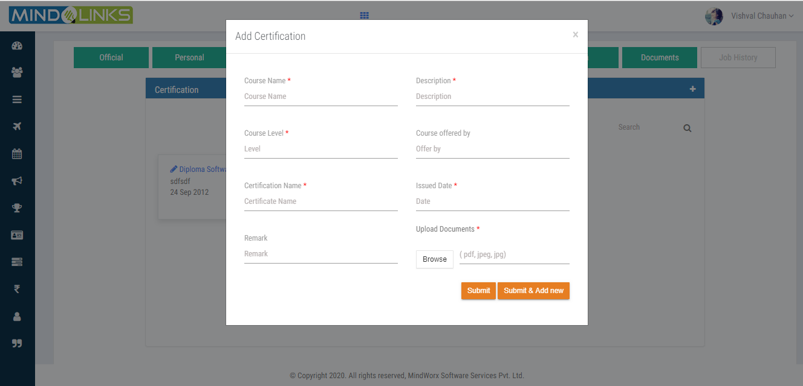

1. On clicking icon user can edit the certification of employee after enter all the details as shows

in below screen .

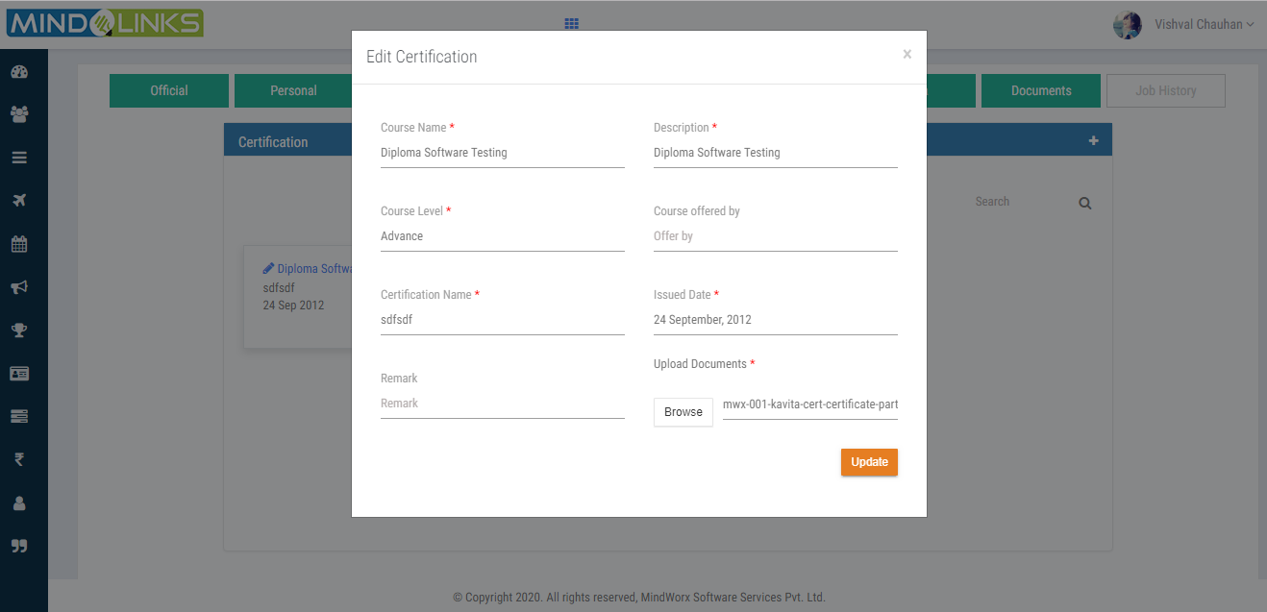

1. Click on update button.

|  |
| --- |
| **Visa** |

1. When user clicks on **Visa** it shows the employee’s visa details.

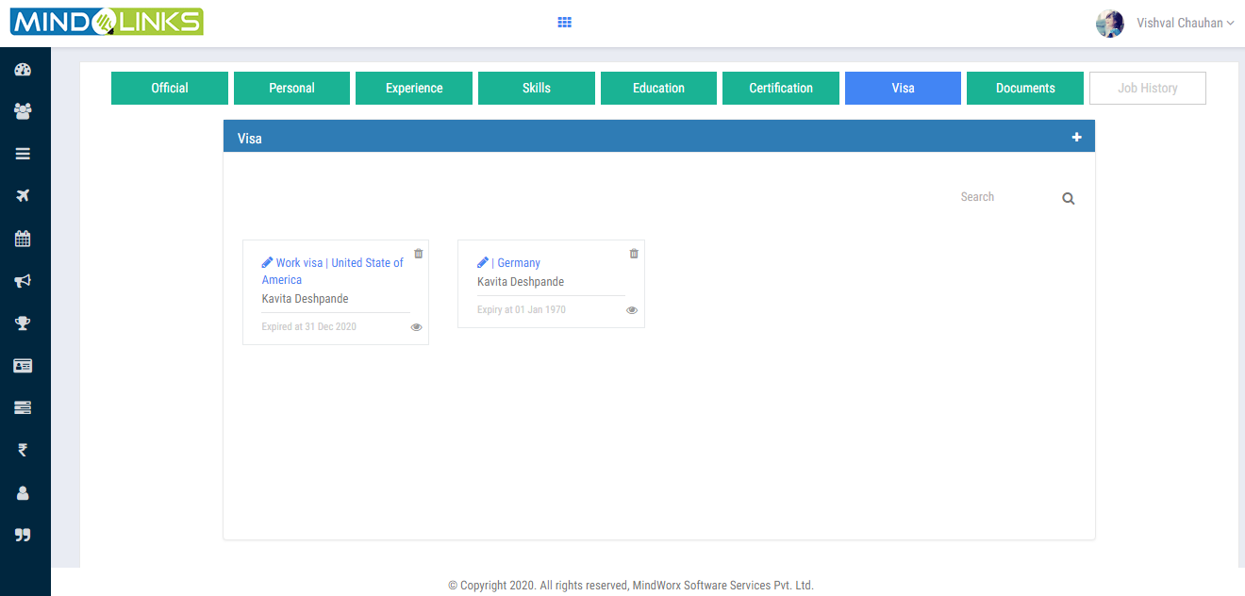

1. If user wants to add visa details then he clicks on  icon and enter the details as

Shows in below screen and click on submit button.

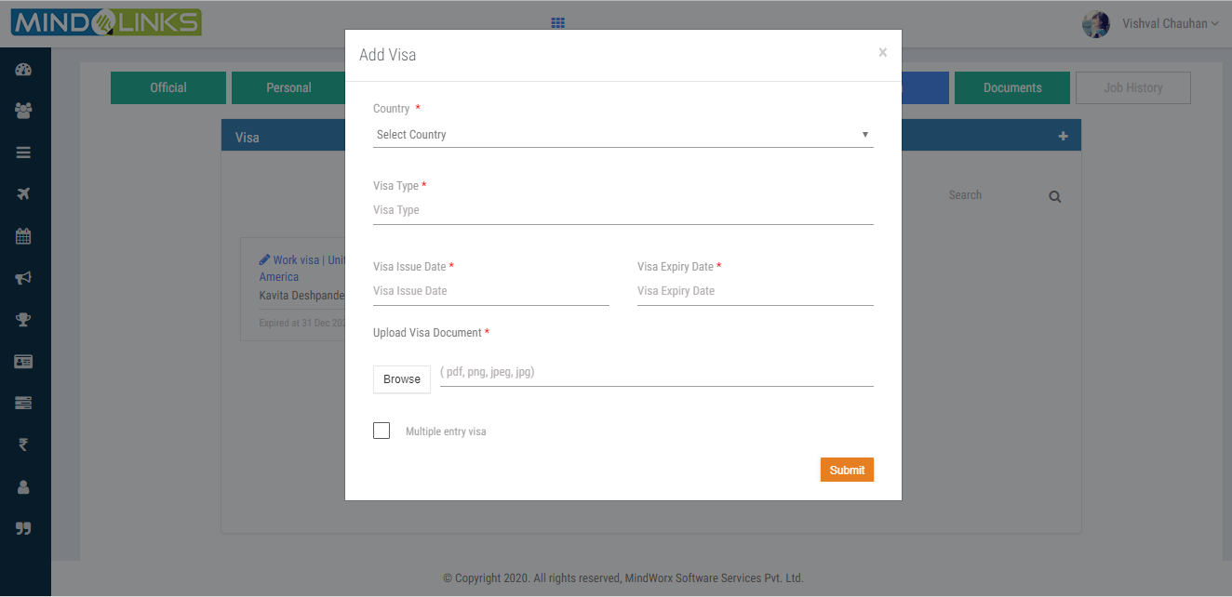

1. On clicking icon user can edit the visa details of employee after enter all the details as shows

in below screen .

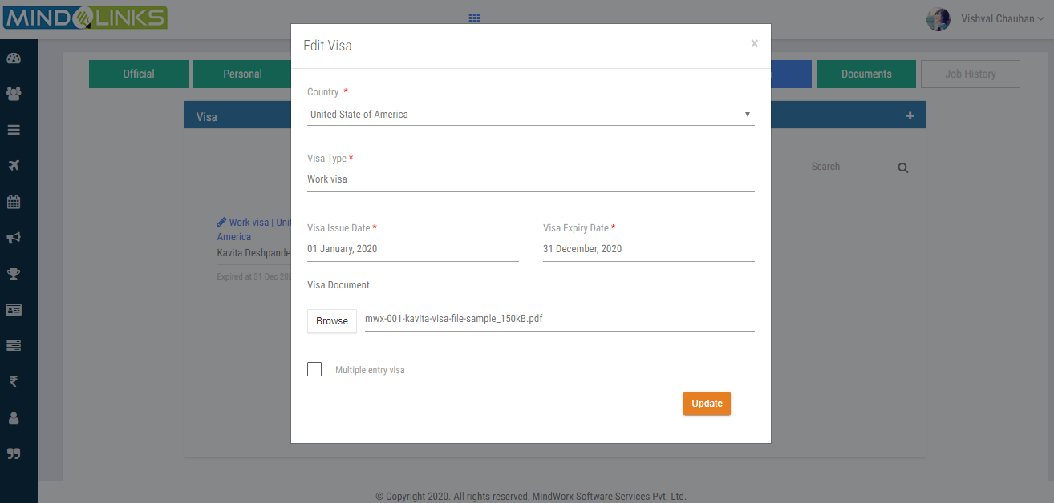

1. Click on update button.

|  |
| --- |
| **Documents** |

1. User can view the list of documents which is relevant to employee details.

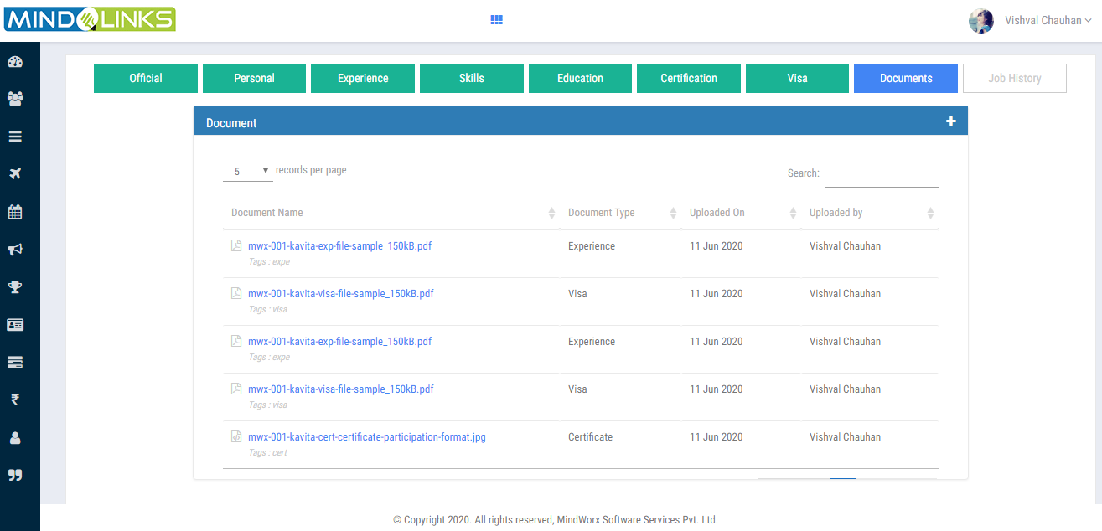

1. If user wants to add document then he clicks on  icon and enter the details as

Shows in below screen and click on submit button.

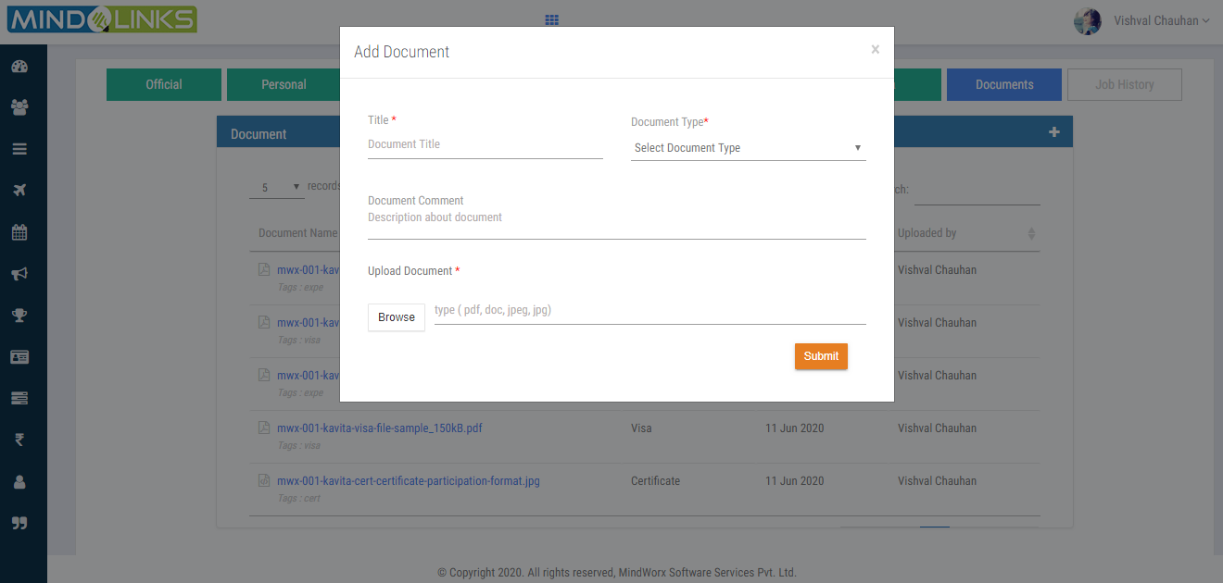

## Employee Exit Checklist

Employees who left the job or terminated from job will display in the employee exit checklist.

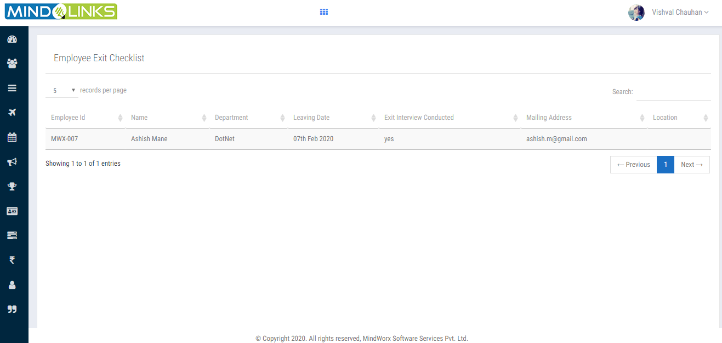

# MASTERS

## Department

It’s a master to create Department and view the list of department with its status i.e. active

or inactive and HR can edit the department list.

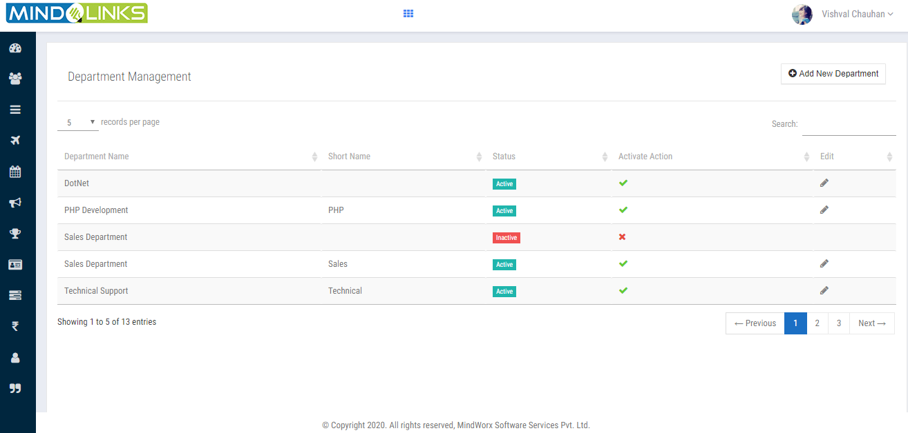

To add a new department clicks on the **ADD NEW DEPARTMENT** button.

Step1: Enter all the details as shows in below pop up screen.

Step2: Click on Submit button.

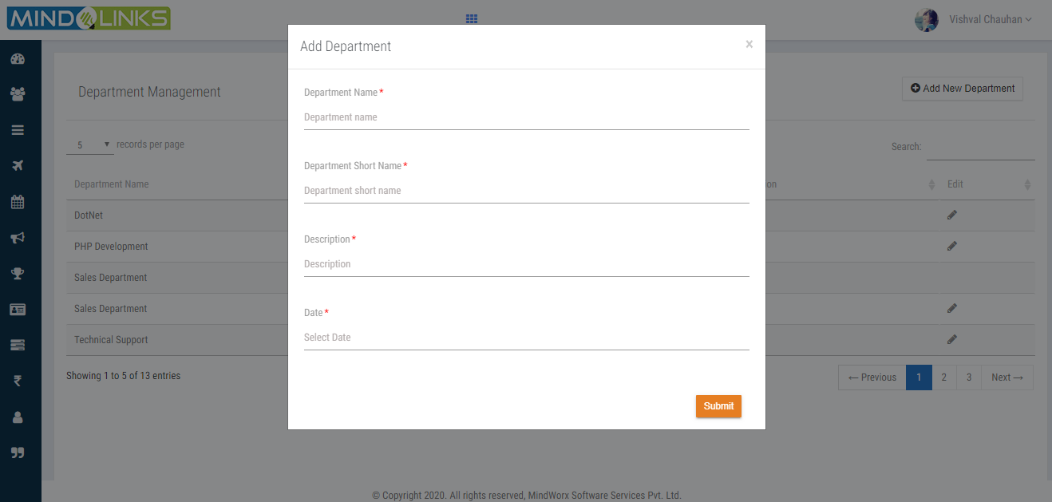

## Awards Management

It’s a master to create list of award which used when organization want to give

awards to their employees. Ex. hall of fame, employee of the month or year. etc

Here user can see List of award.

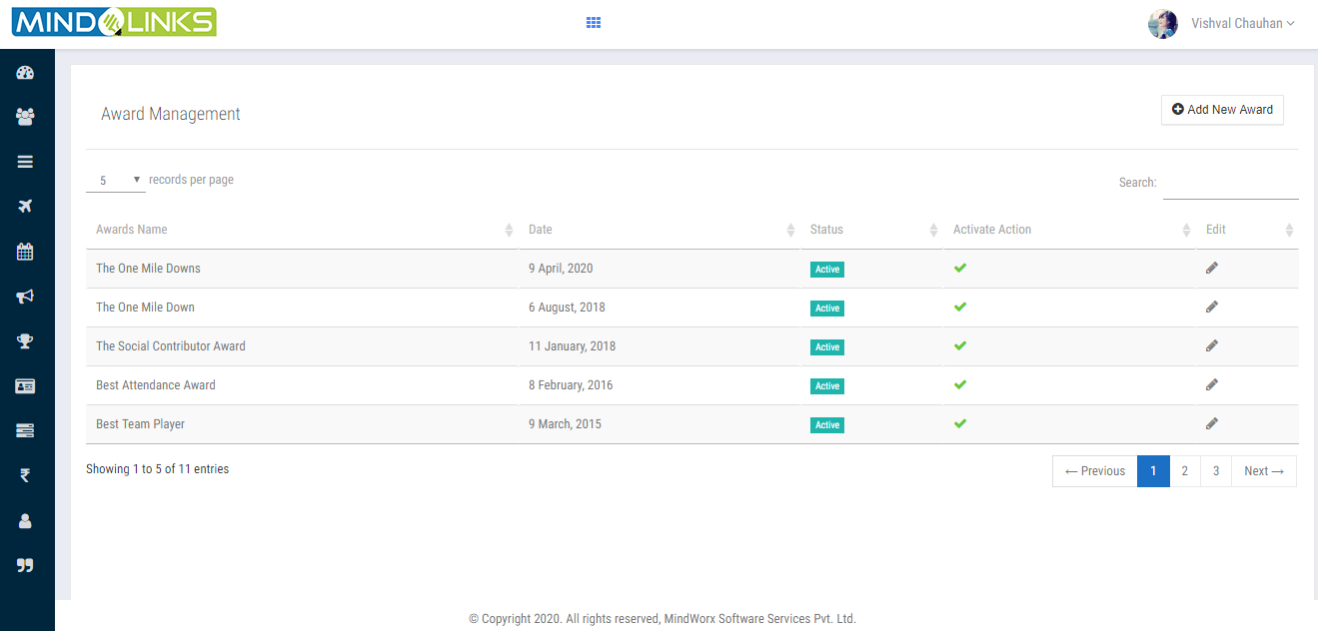

To add a new award clicks on the **ADD NEW AWARD** button.

Step1: A pop up window opens as shows in below screen then enter all the details.

Step2: Click on Submit button.

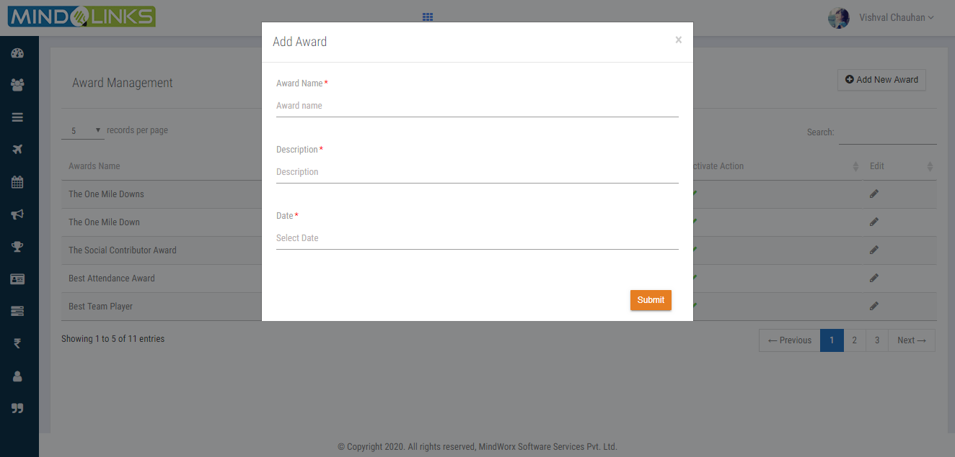

## Policy Category

Here it shows the different policies name list with its status i.e. active

or inactive. icon shows the policy is active, icon shows policy is inactive.

User can deactivate or activate the policy record by clicking or as shows in

below screen.

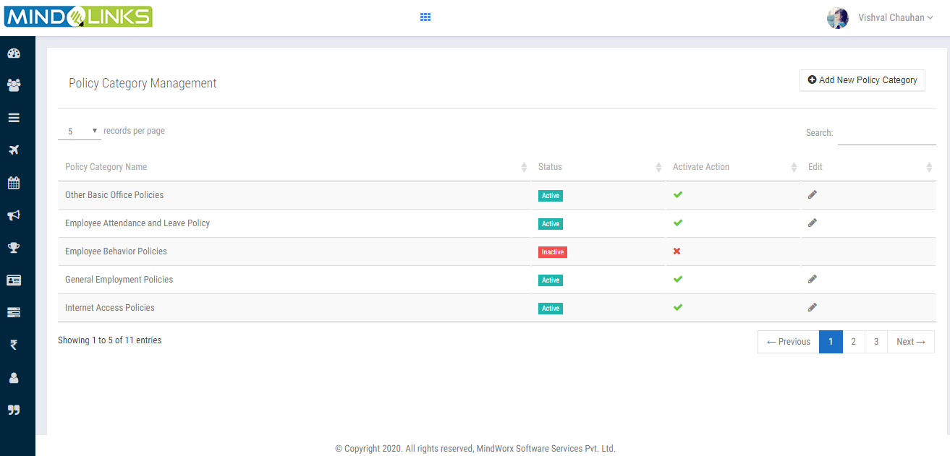

To add a new policy category clicks on the **ADD NEW POLICY CATEGORY** button.

Step1: A pop up window opens as shows in below screen then enter policy category name.

Step2: Click on Submit button.

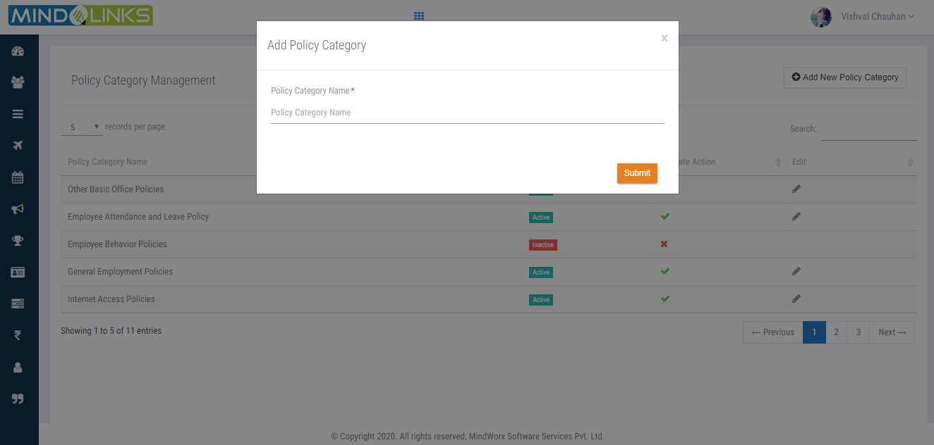

## Main Category and Sub Category

Main & Sub categories are for Appraisal soft skill rating.

Step1: User can see the list of category with its status i.e. active or inactive.

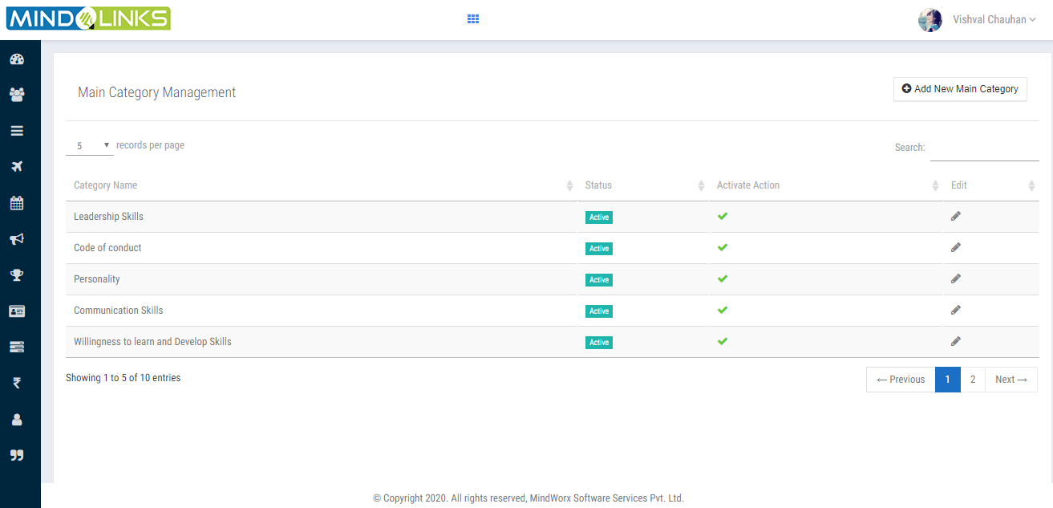

Step2: User can edit the main category by clicking icon.

1. A pop up window opens as shows in below screen then enter category name and its

Description.

1. Click on Update button.

## 

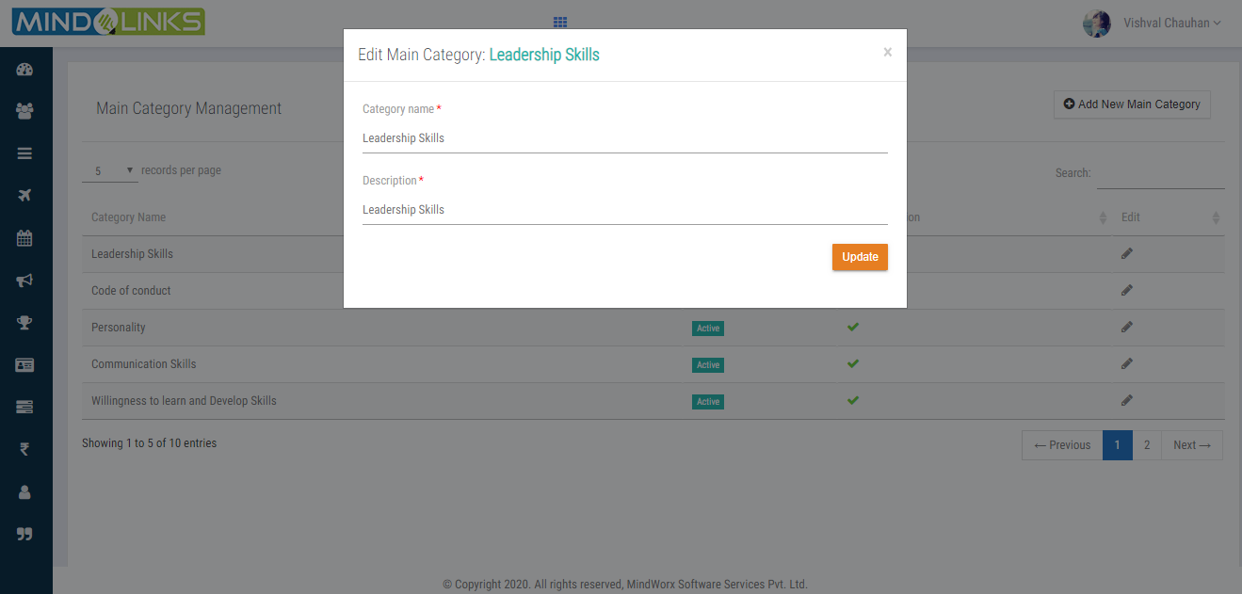

## Conference Booking

## 

## Step3: To add new main category click on ADD NEW MAIN CATEGORY button.

1. A pop up window opens as shows in below screen then enter main category name and its

Description.

1. Click on Submit button.

## 

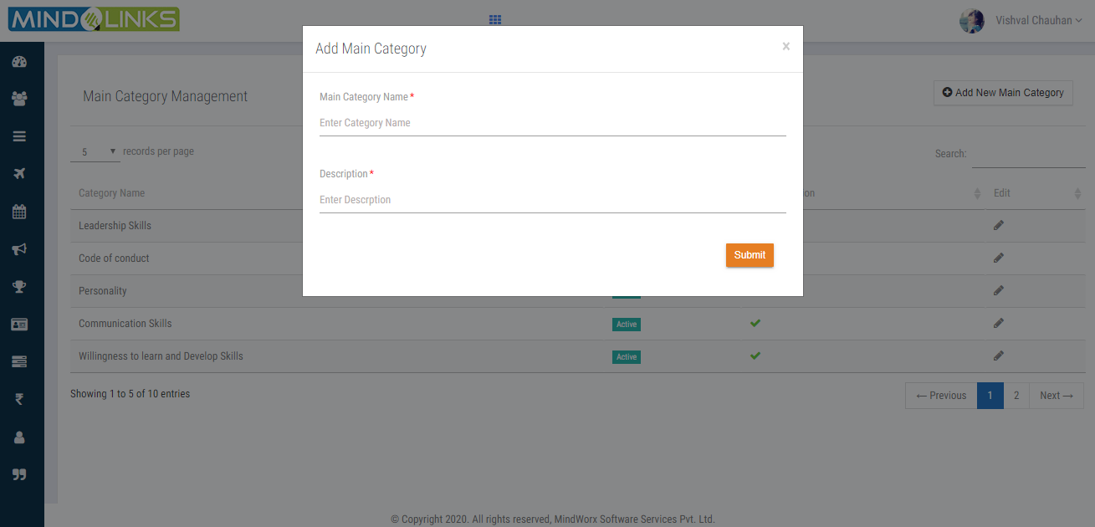

## Sub category

## 

User can see the list of sub category For example: Leadership skills is larger category so

Its subdivision will be client interaction, team building etc.

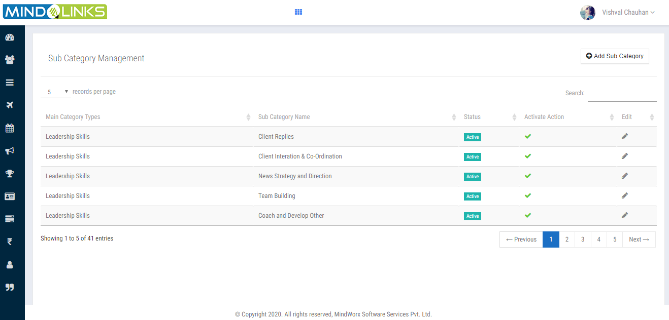

Step1: User can see the list of category with its status i.e. active or inactive.

Step2: User can edit the main category by clicking icon.

1. A pop up window opens as shows in below screen then enter main category

name Sub category name and its description.

## Click on Update button

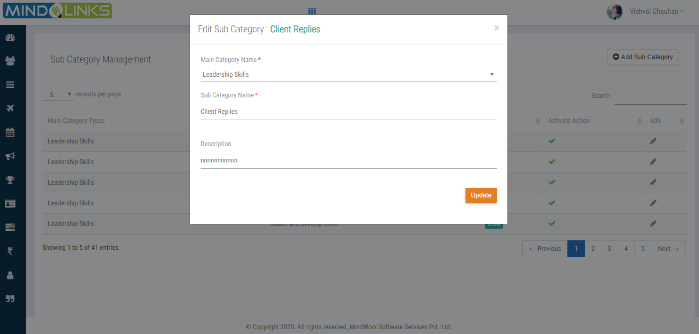

## Step3: To add new sub category click on ADD SUB CATEGORY button.

1. A pop up window opens as shows in below screen then enter main category name

Sub category name and its description.

## Click on Submit button

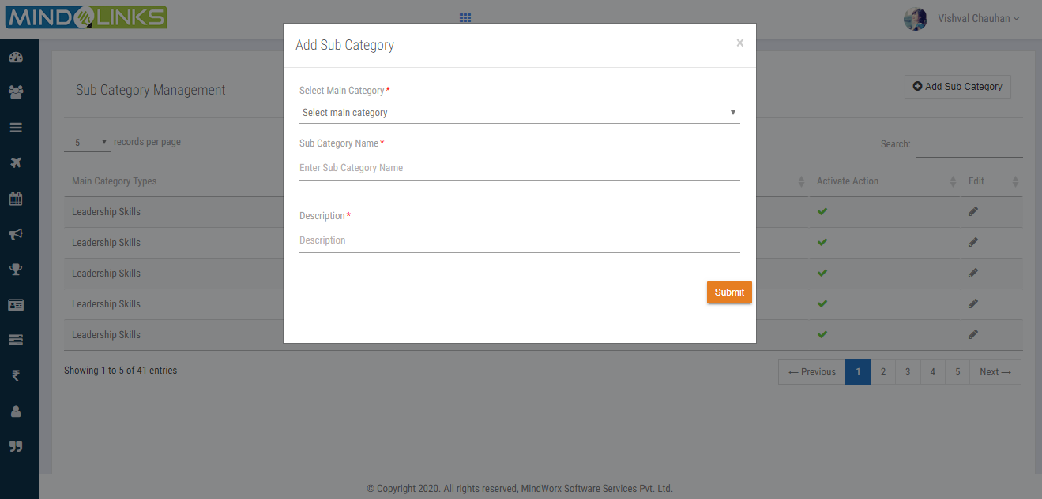

## 

## Conference Room

It shows the conference room management i.e. it is a discussing platform where that involves

everything from meeting room scheduling to digital signage to workplace analytics.

In short this management help organizations to manage and use their office spaces in a

smart way.

Step1: User will see the list of Conference Room with its location and its status as shows

in below screen.

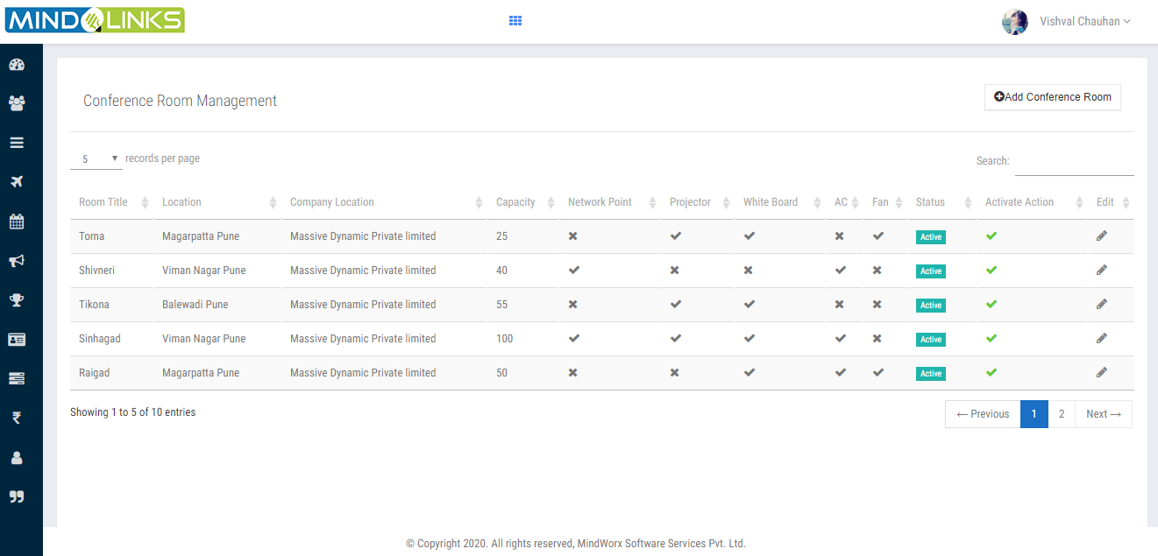

Step2: User can edit the main category by clicking icon.

1. A pop up window opens as shows in below screen then enter details and mark

on availability as per user need.

## Click on Update button

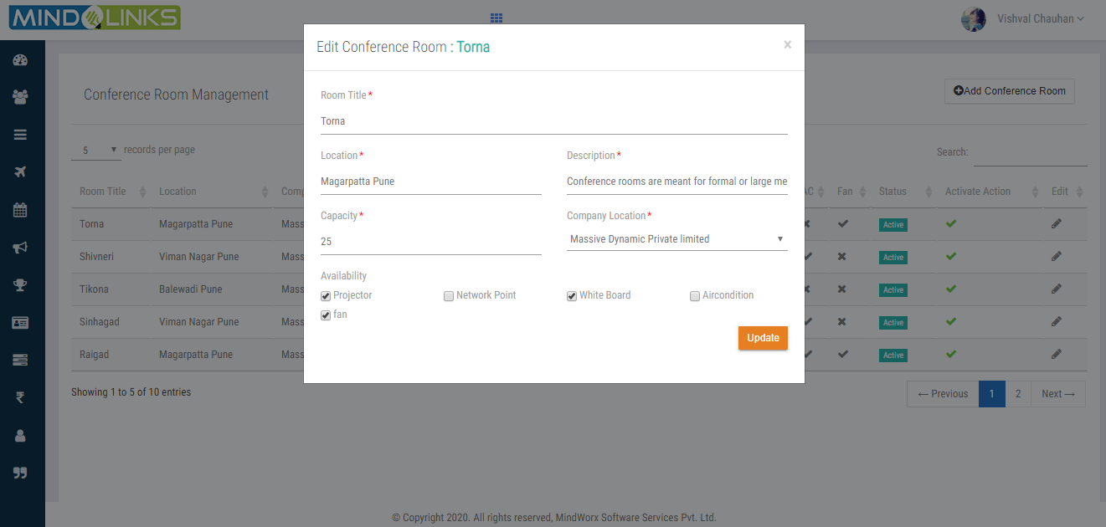

## 

## Step3: To add new conference room click on ADD CONFERENCE ROOM button.

1. A pop up window opens as shows in below screen then enter

## Click on Submit button

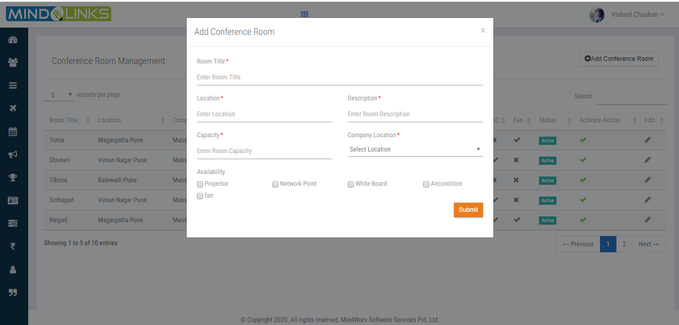

## Hobby

Step1: It is master to create the hobby ;User view the active hobby list.

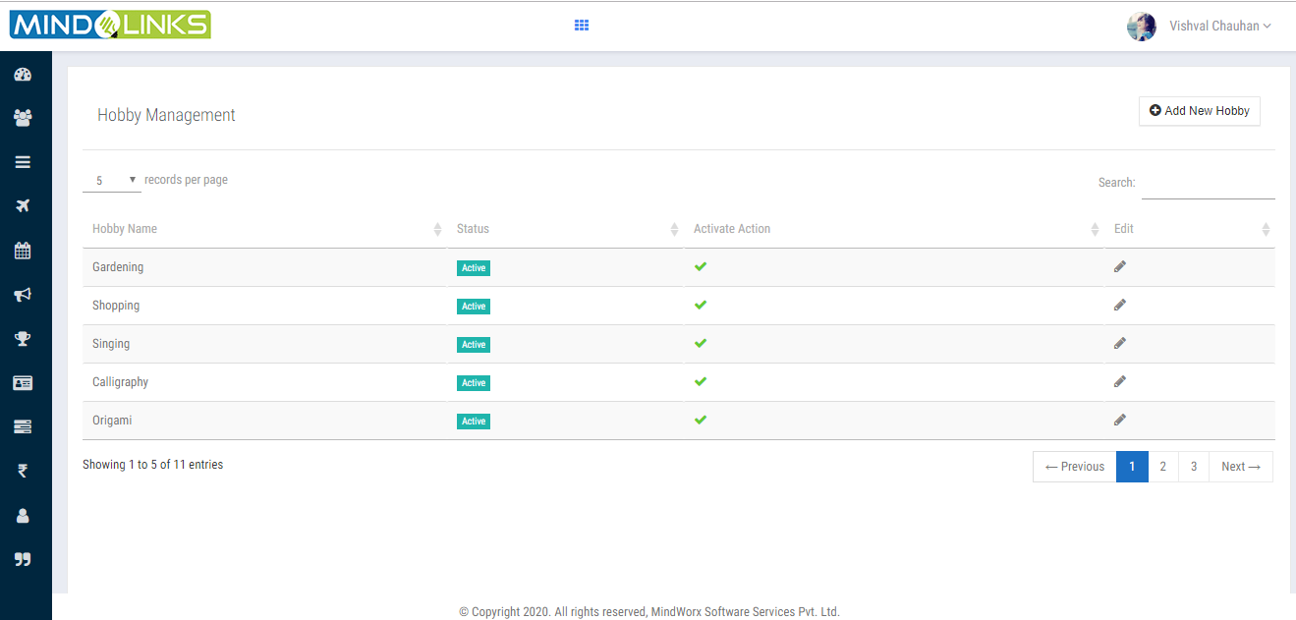

Step2: To edit the hobby click on icon a pop up window will appears as shows in below

Screen enters the hobby name and its description.

Step3: Click on Update button.

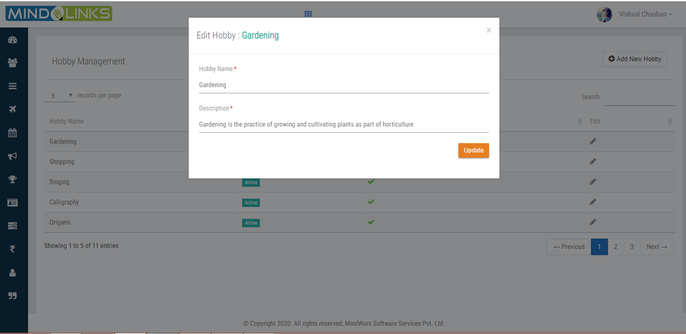

Step4: To add new hobby click on **Add New Hobby** then enter all details and click on Submit button.

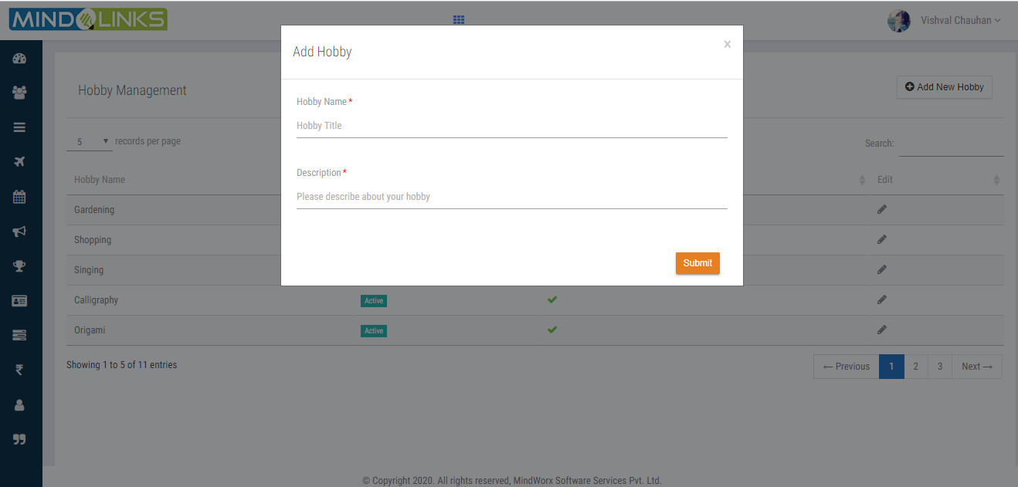

## Idea Category

Create an Idea category master to specify the idea category List.

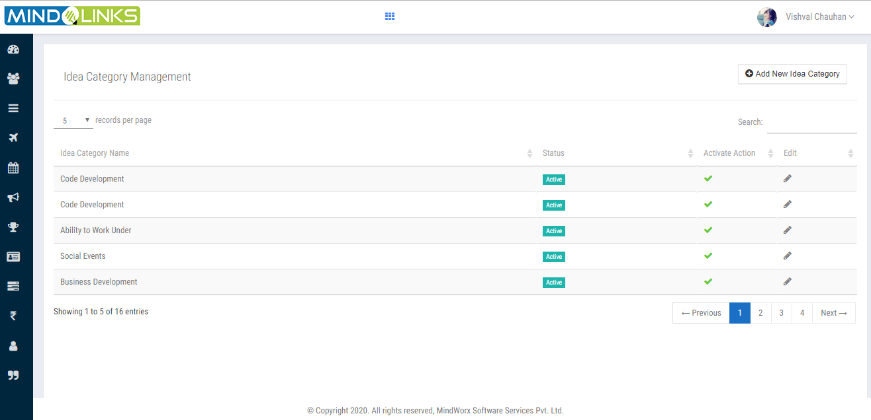

Step1: To edit the idea category clicks on and enter the idea category name then click on Update

Button.

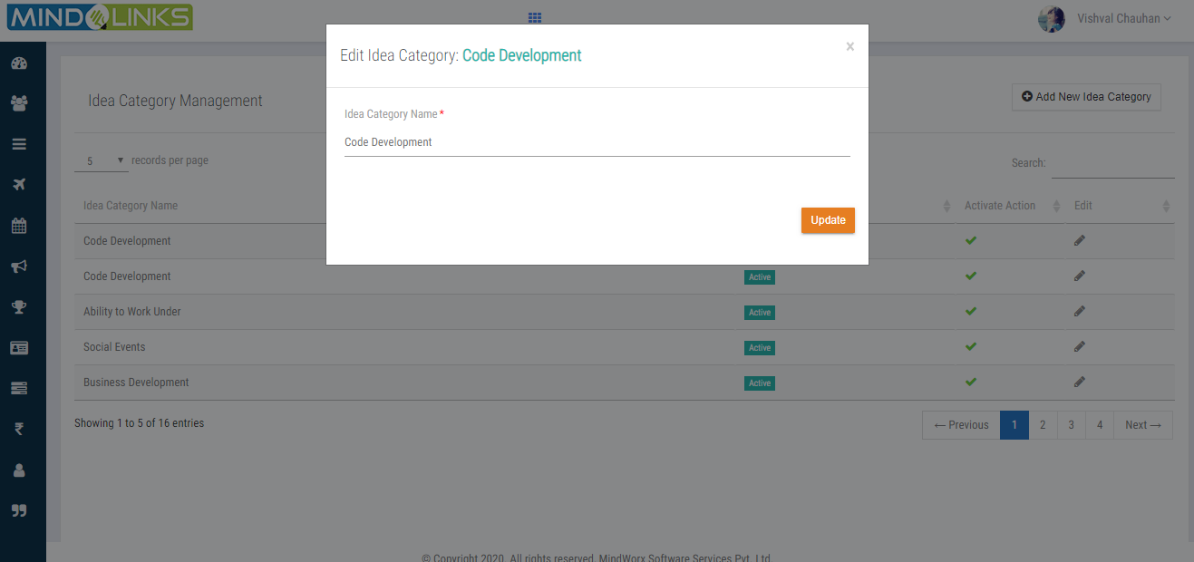

Step2: To add new idea category clicks on **ADD NEW IDEA CATEGORY** enter idea category name then

Click on Submit button.

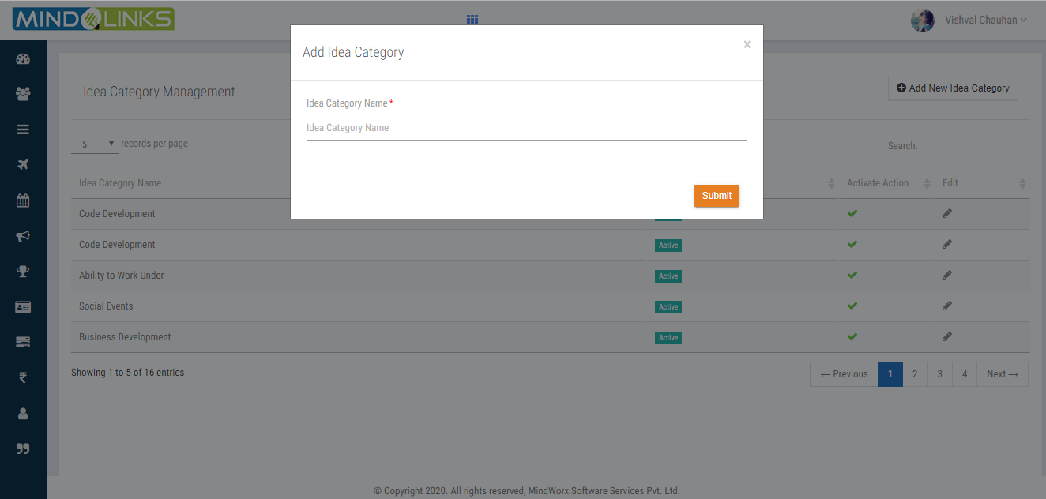

## Job Title

Create a Job Title master to specify the Job List.

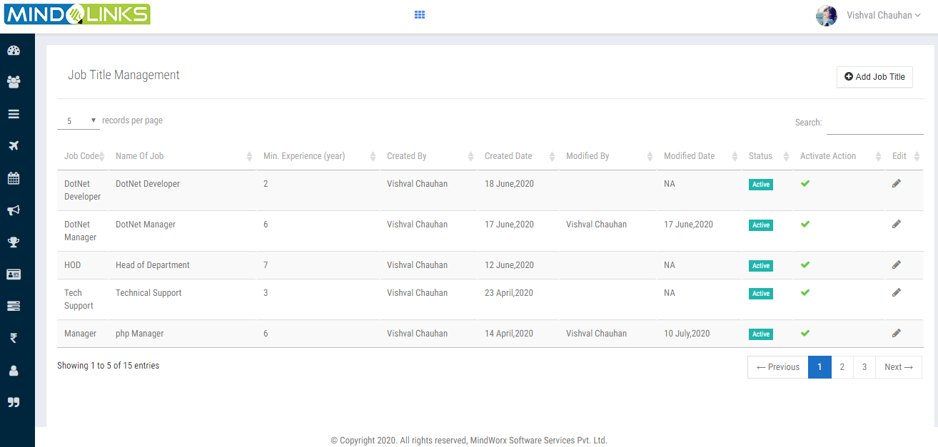

Step1: To edit the idea Job Title clicks on and enter details showed in below screen then click on

Update Button.

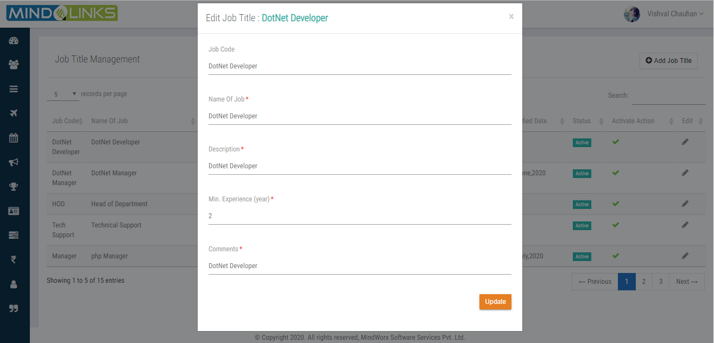

Step2: To add new Job Title clicks on **ADD JOB TITLE** enter details then click on Submit button.

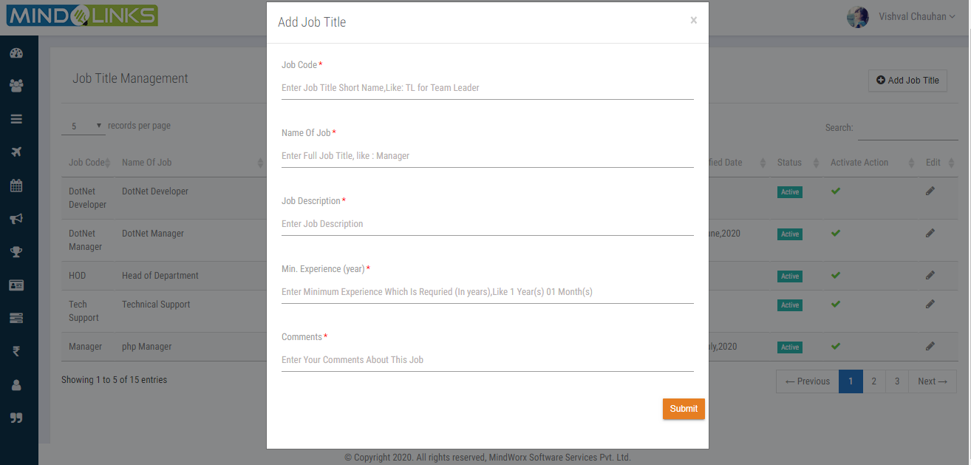

## Job Position

Create a Job position master to specify the Job position.

# Manage Leaves

## Add Leaves

User views the published Leave List year wise with its code and number of allocated leaves.

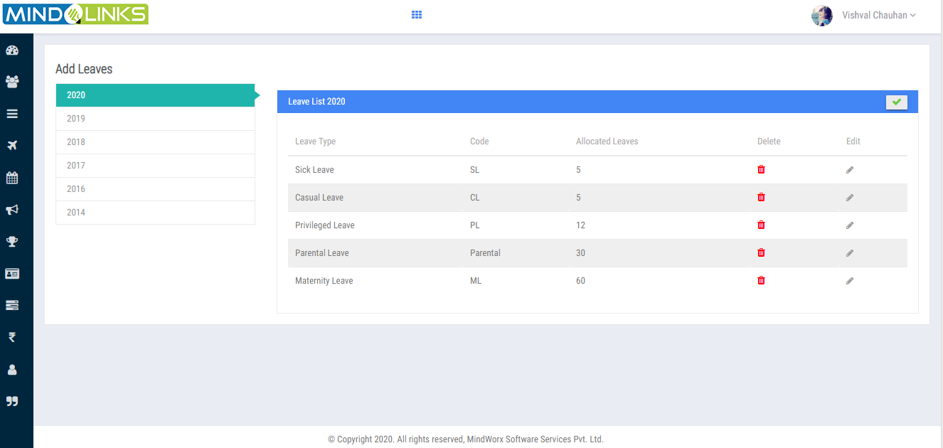

**Note:** Once leaves got published for respected year user cannot edit or delete the leave.

## Allocated Leave

Step1: Here it shows the number of allocated leaves assigned to particular employee.

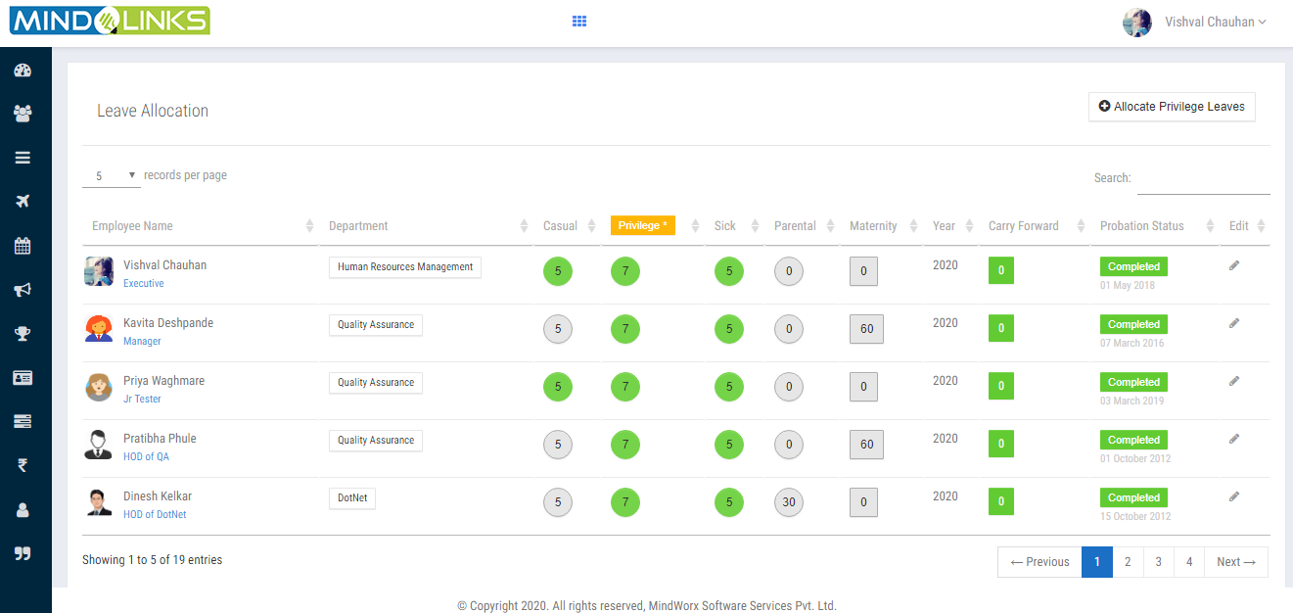

Step2: To edit the allocated leaves click on icon and allocate the leaves.

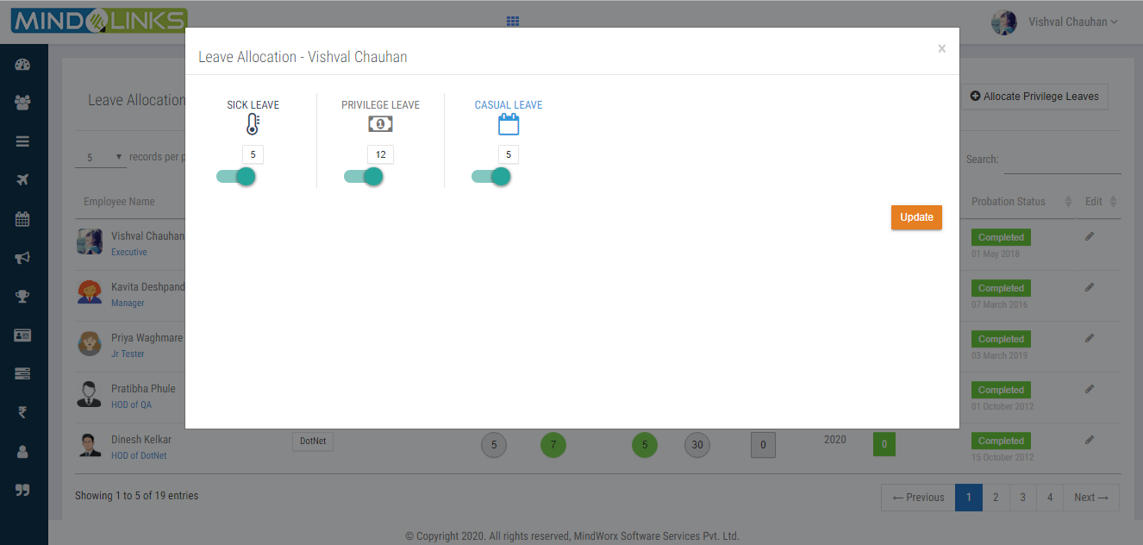

Step3: Click on update button

## Manage Holiday

Step1: User will view the list of holiday year wise.

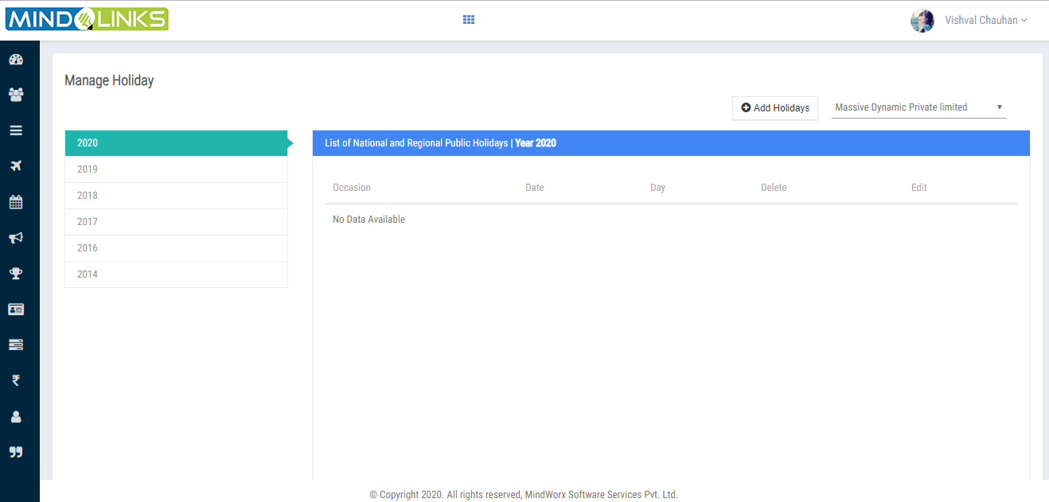

# Timesheet

The timesheet facilitates the easy management of the time spent by the employee. It

Easy tracking of the time spent by an employee on a project or on a certain task/subtask.

Access can be restricted to certain users for adding timesheet.

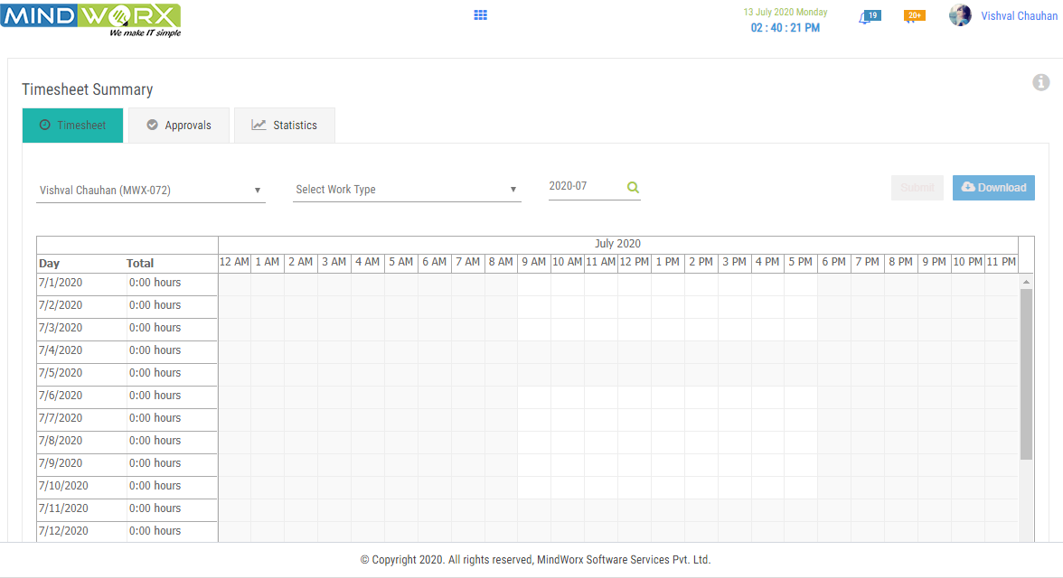

**Approvals**

The approving manager must evaluate, approve, and forward the request to the HR group.

or HR leave approved and evaluate by CEO.

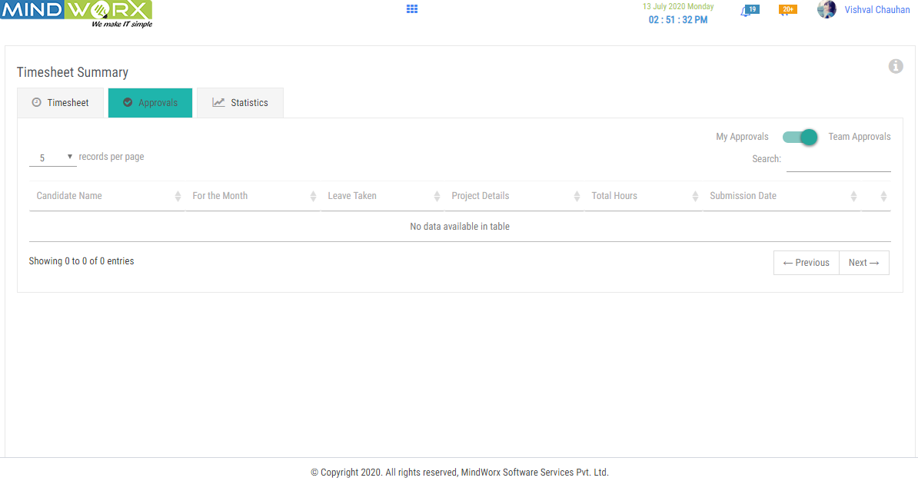

**Statistics**

The total time to complete a task can be specified at the time of creating the task. Then the

Assigned employee can add the timesheet of that task so that the manager and employee

Can easily track the total time spent, the Hours complete shows (in graph), and the remaining

Time or the extra time taken by the employee etc...

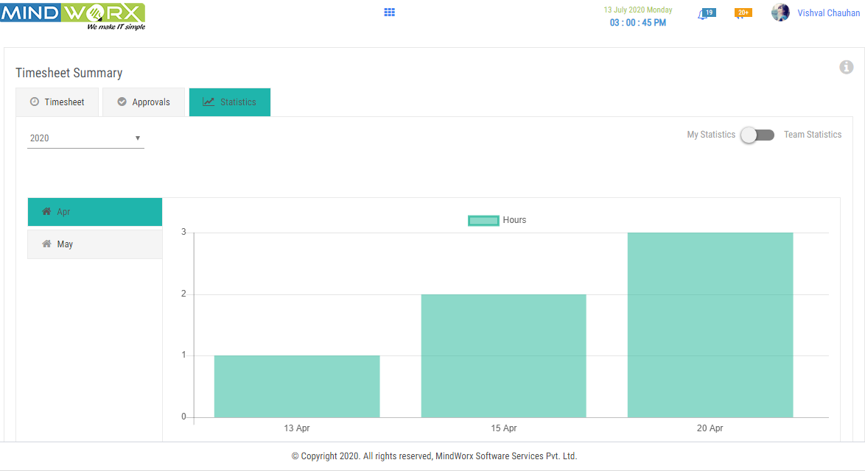

# Recruitment

It shows the List openings, define the recruitment stages and track the applicants.

Review the recruitment process from time to time with the help of HR reports and

Improvises the selection strategies.

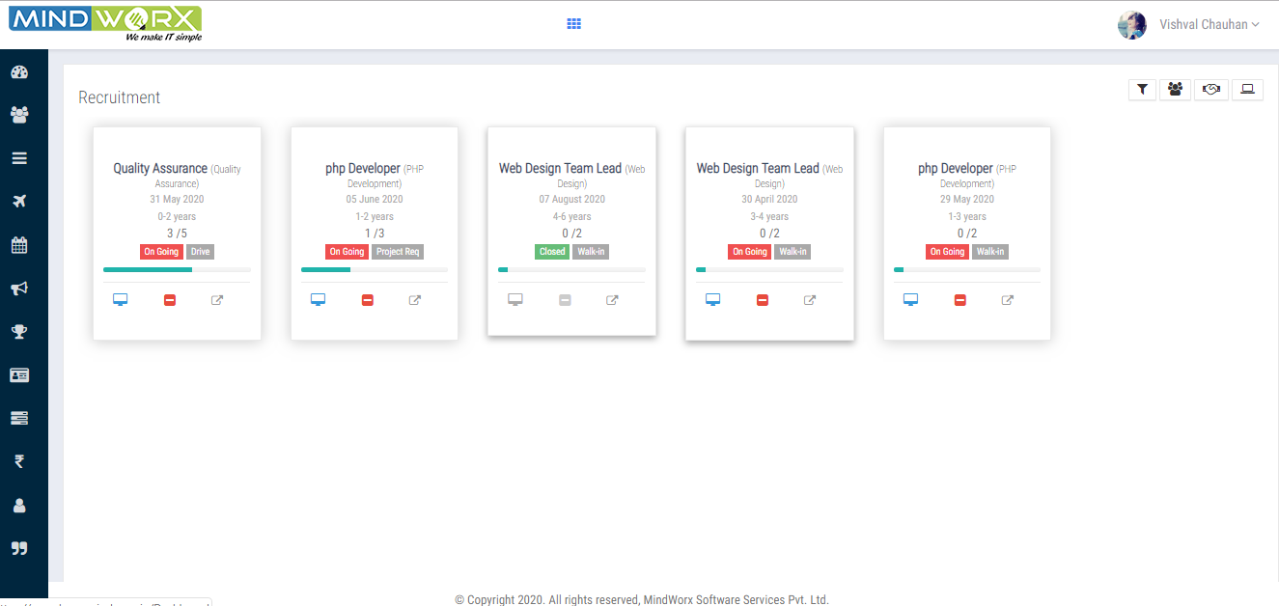



* This shows the list of all the recruitment post.
* This shows the list of post where recruitment is done by drive.
* This shows the list of post where recruitment is done by walk in.

 This shows the list of post where recruitment is done as project request.

When click **on the post**, it shows the screening summary, i.e. pie chart shows how many

Positions are filled, how many candidates are shortlisted and bar graph shows no of

candidates for that particular stage.

Stages are round 0 to 3, HR, offer, joining and rejected.

## 

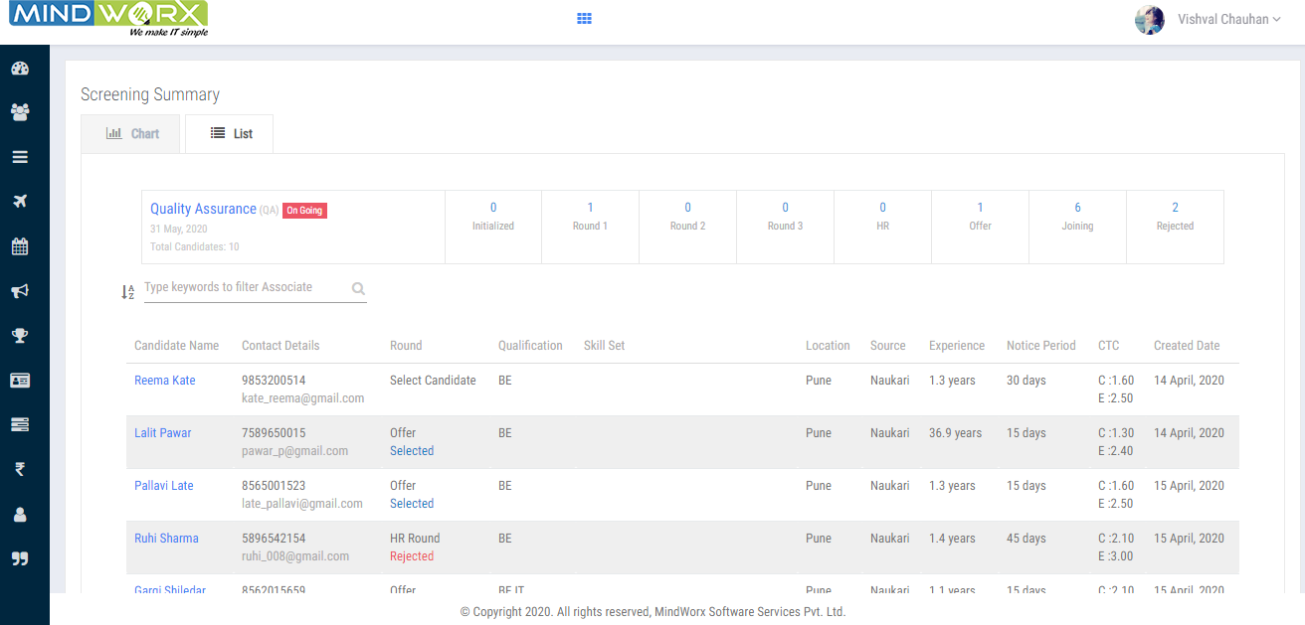

(**Screening List)** It shows the candidate list with interview rounds results.

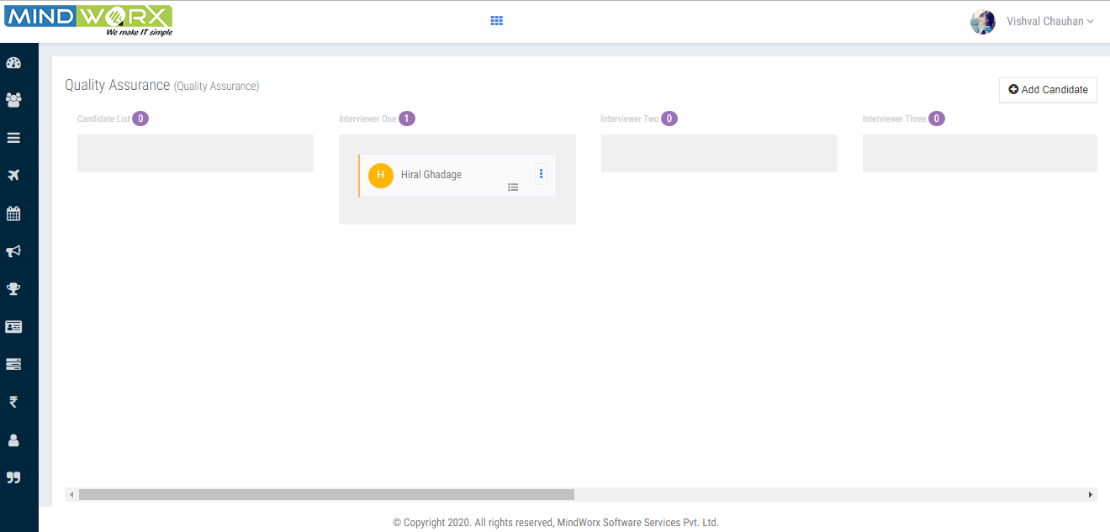

* (**Close the opening)** by clicking this icon HR can close the recruitment .

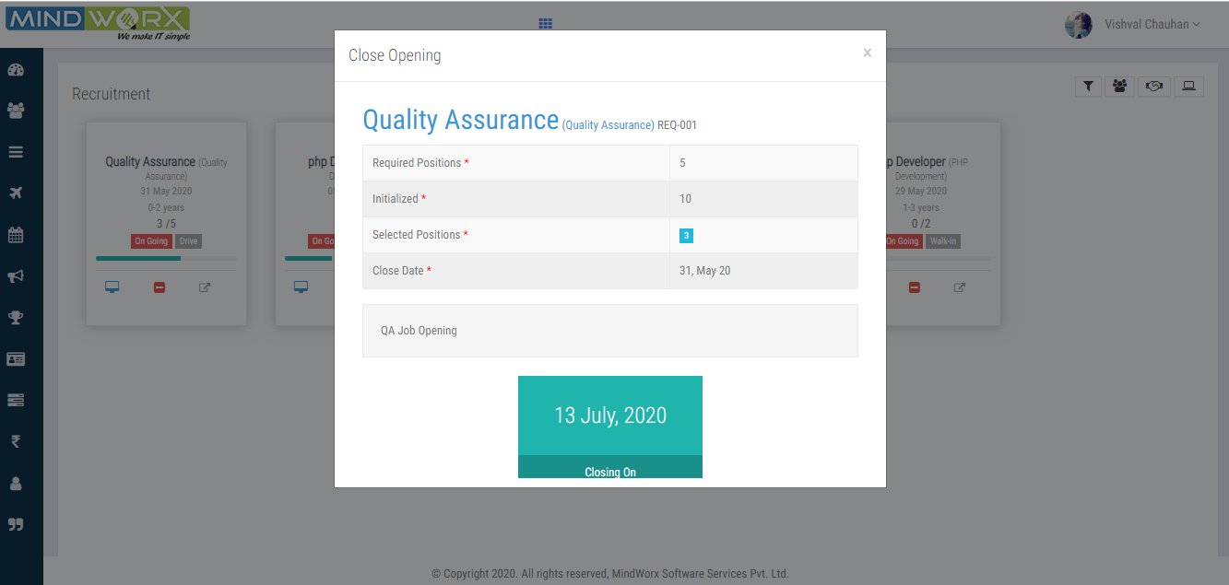

* (**View the list)**by clicking this icon HR can view the required candidates with its job

Description and its status.

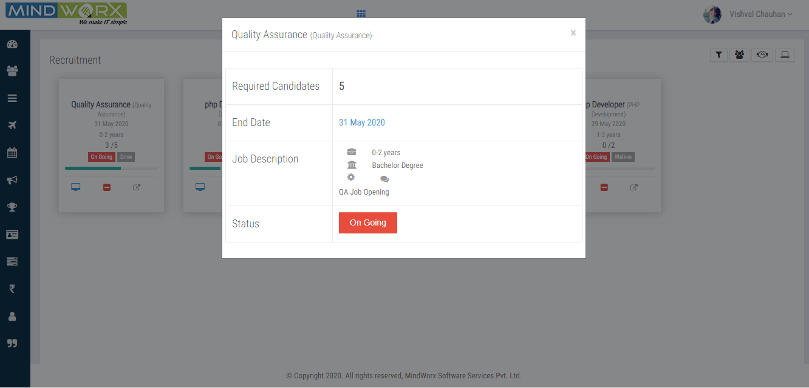

# Hall of Fame

List of hall of fame that an organization honoring the achievements of individuals in a particular

Activity or field.

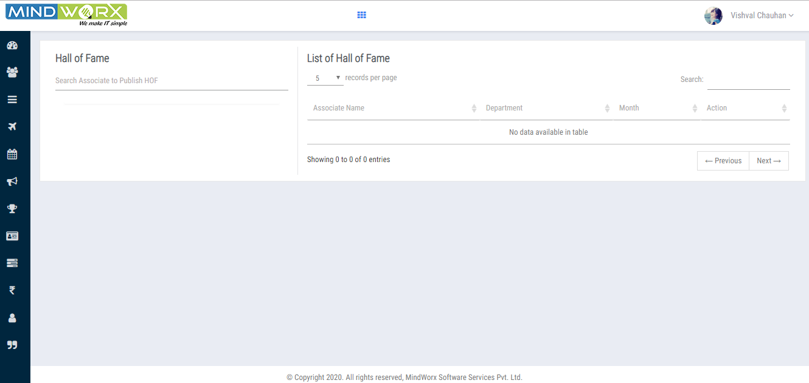

# Attendance

Associate will use the attendance modules to make attendancereports,both biometric and punches.

HR and associates can upload/ view both the biometric and punches report.

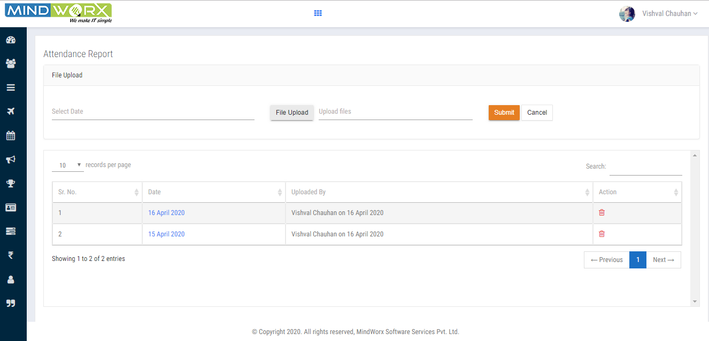

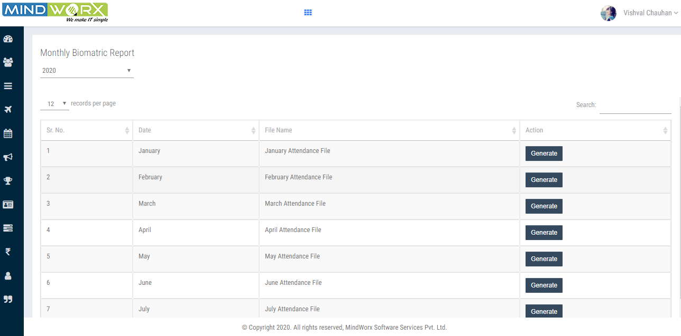

# Manage Project /Client

The end user can add the new client/ project and can search /view the client details

along with the status i.e. active or inactive also analyze the date when the project

Has started.

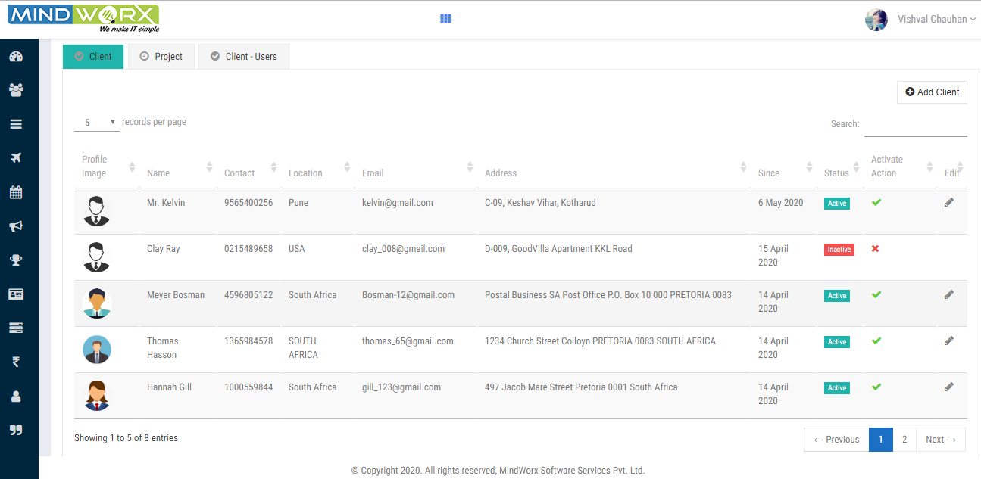

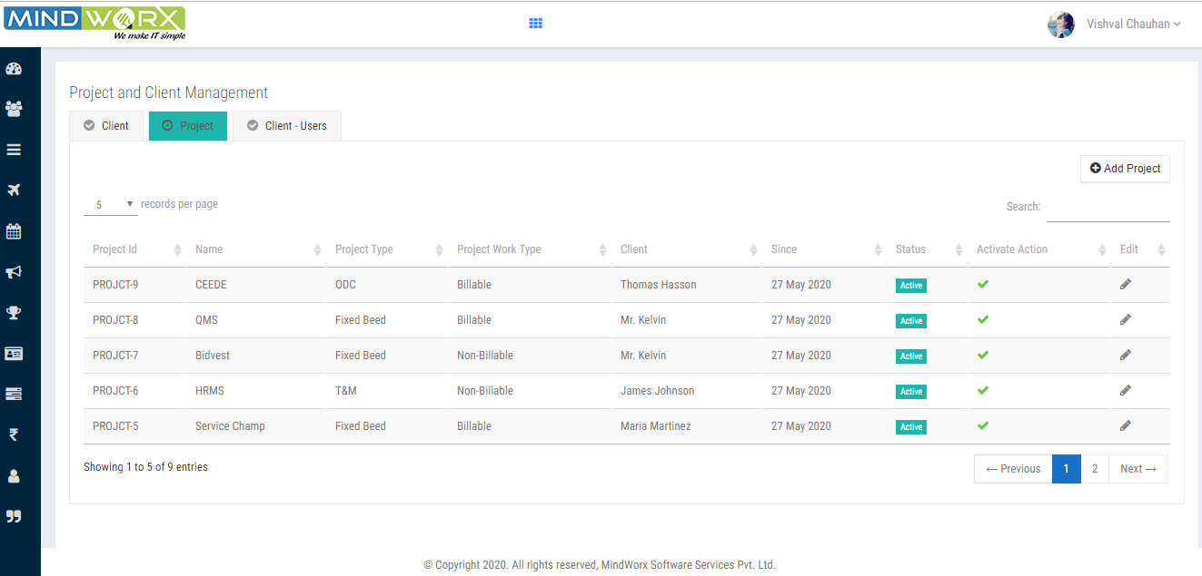

These are the users List who are working for clients. They are not organization's user.

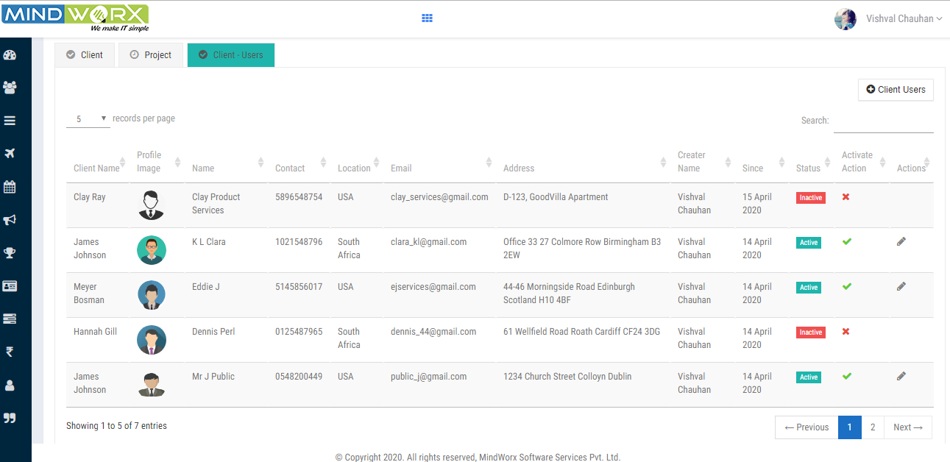

# Appraisal

To be updated…..

# Asset Management

## Asset Master

HR used to keep track of the equipment and inventory (assets) vital to day-to-day operation of their businesses. Exactly how those **assets** are managed and can also add new assets.

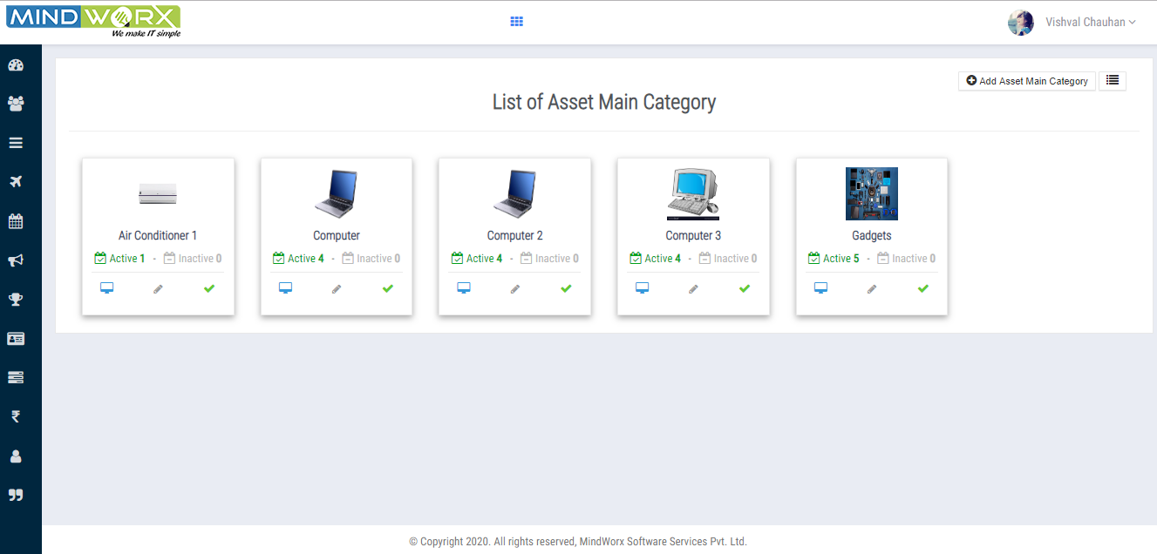

This icon is used to view sub category of assets. For example: Air conditioner is a main category

and its subcategory is remote.

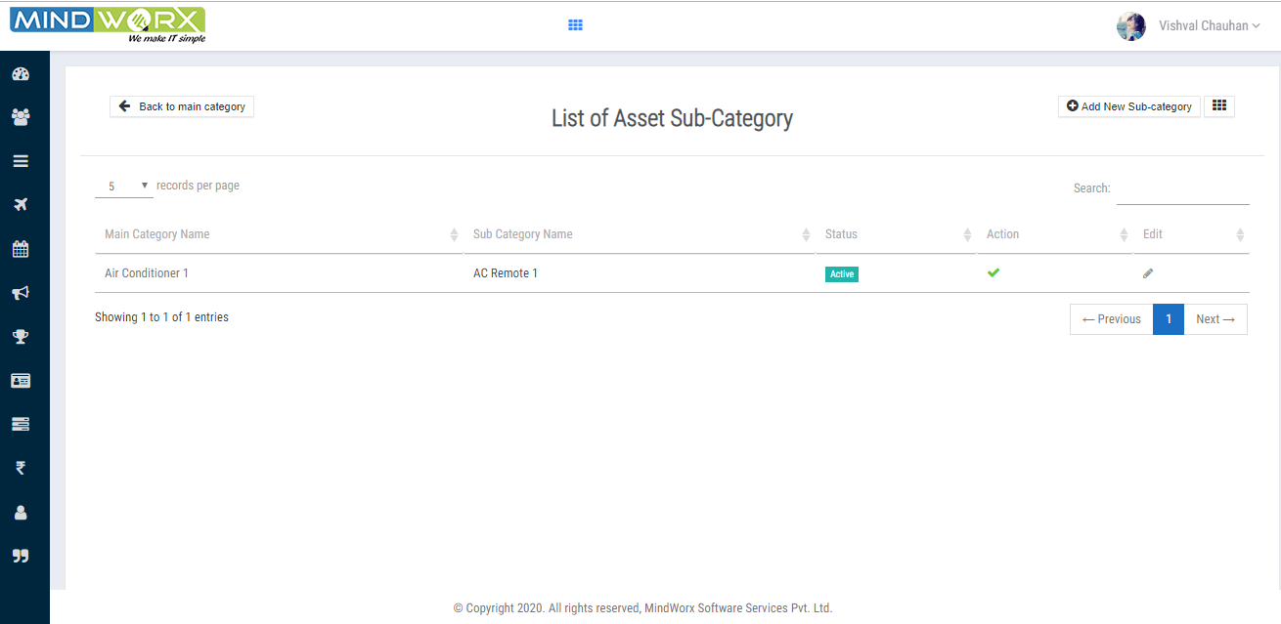

This icon is used to edit the main category.

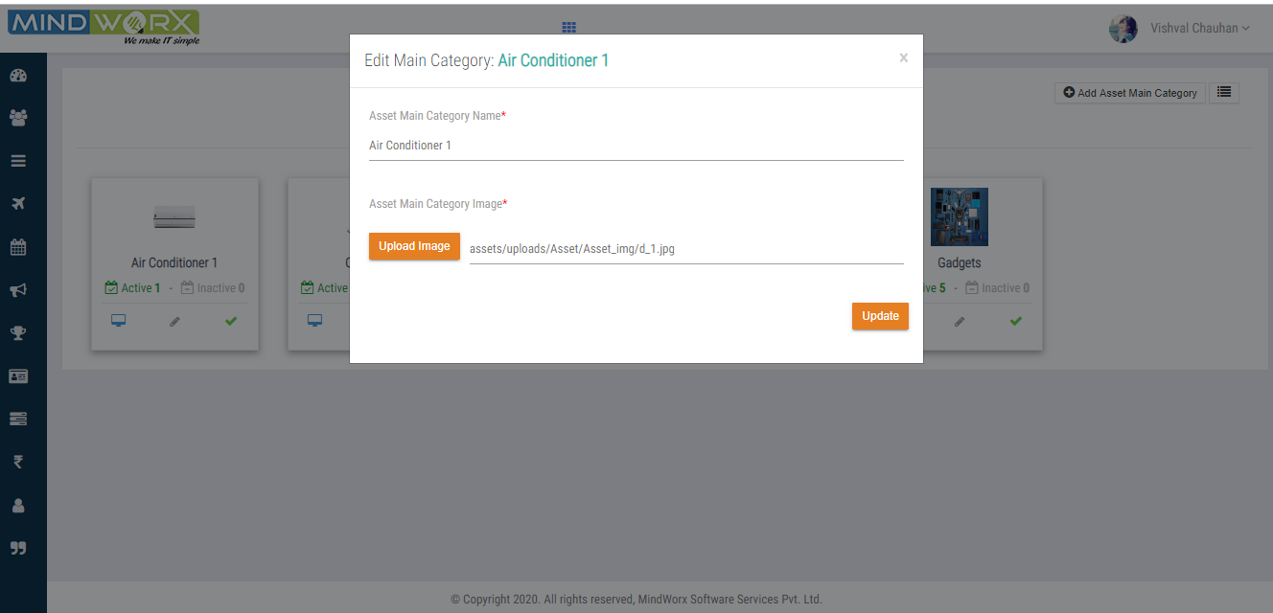

This icon is used for deactivate and activate the record.

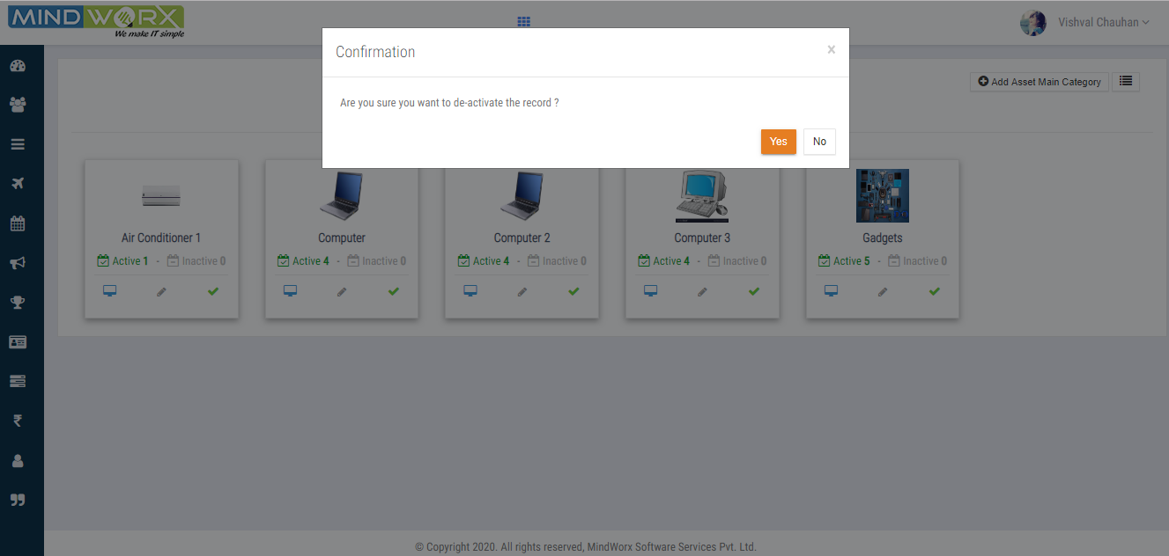

## Asset Allocation

HR will allocate the assets locationwise and view user name list and perform

Action (where HR can view and allocate the asset per user wise)

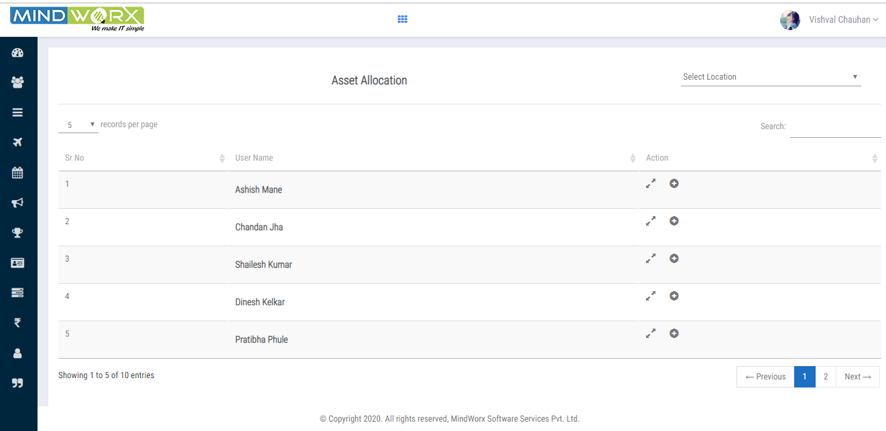

HR can allocate the assets by clicking this icon.

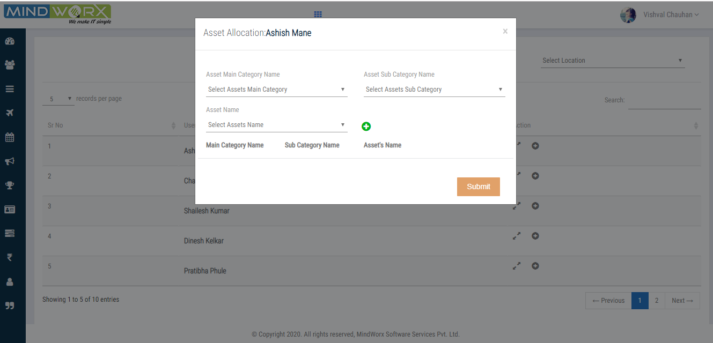

## Asset Audit

It shows the assets audit report monthly wise.

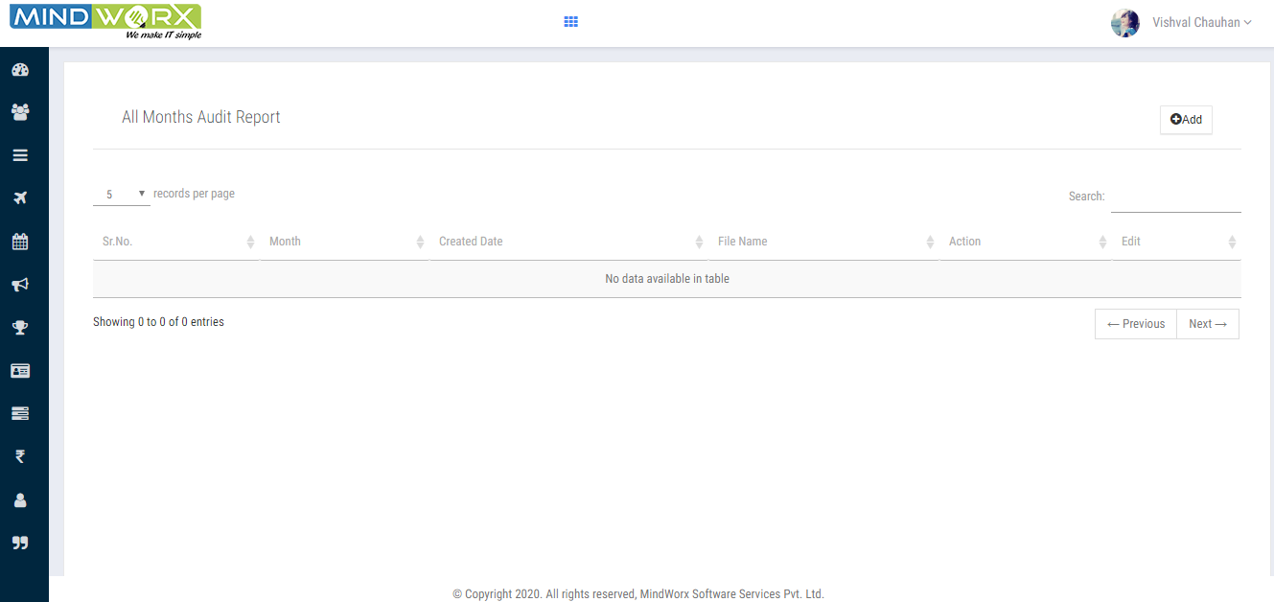

# Quotes

A quote’s image or text that has written by associates isfirst approved then published by HR.

